**IKSHA ‘**

**S**

**NUSANDHAN**

**A**

**’**

**O**

**DEEMED TO BE UNIVERSITY**



**Registration No.:** 1841017031

**Name:** Dibyajit Mohanty

**Semester:** 4th Sem

**Section:** ‘C’

**Faculty of Engineering & Technology (ITER)**

**Jagamohan Nagar, Jagamara, Bhubaneswar, Odisha - 751030**

**Department of Computer Science & Information Technology**

***Submitted by: -***

**Admission Batch: 2018-2022**

**Session: 2020-2021**

**Branch:**  CSIT

**Computer Science Workshop 2 (CSE 3141)**

**End-Term Project Report**

|  |  |  |
| --- | --- | --- |
|  | **INDEX** |  |
| **Sl. No.** | **Content** | **Pages** |
| **1.** | Problem Statement. | 3 |
| **2.** | Problem Analysis. | 4 |
| **3.** | Flow Chart of the Problem. | 5 |
| **4.** | Coding (JAVA AS PROGRAMMING LANG.) | 6 - 122 |
| **5.** | Snapshot of the input and output. | 123 -133 |
|  |  |  |

**1. PROBLEM STATEMENT**

**Library Management System: -**

This project is a simple Library Management System. This project consists of 2 different modules. The first module is the login module which should have two type of accessing modes, administrator, and user. Library management system is managed by an administrator. The administrator can insert update and monitor the whole process. When a user log in to the system, he/she would only view details of all the books present in the library and the books issued by the user. The Admin Menu should be designed to show details of users, books, issued books, add books, return books, add user, and create or reset the database.

**2. PROBLEM ANALYIS**

**Introduction: -**

Library Management System is a facilitate program of java application. There are two modules in this application. A module of Student Login where students can access through their username & password. They can only view the books available in library and also those books been issued by them. And we have another module as Admin Login. Administrator have a default username & password assigned to them. They can do a lot of stuffs such as add new users, add new books ,remove users , remove books, issue books , return books accept , show a table of statistics , reset or erase the database(remove records in library).

**Data Base: -**

MySQL is an open-source relational database management system. My project is connected to the database of sql through a connector jar “mysql-connector-java.jar”. I have been connected the jFrames to the local host of my server name “dibyajit”.

**Works: -**

1.The Interface of the Library Management System is a type of GUI based interface for user, by using which user able to login to system with proper authentication.

2.Specify operation according to types of use i.e., if the user is administrator, he/she will be able to insert, update, and display data from database. If the user is a general user, he/she will only be able to see the related information of a user.

3.User should be able to get the status of its issued books in a nicely formatted text file. You could find the location of the .txt file in my project file.

4. MySQL data base is used for storing data.

**3. FLOW CHART OF THE PROBLEM**

ERROR

LOGOUT

LOGIN OPTION

OP

NO

NO

YES

YES

YES

YES

CHOOSE OPTION

PRINT ISSUED BOOK REPORT,

CHECK AVAILABLE BOOKS

USERID && PASSWORD =TRUE

USER

CHOOSE OPTION

ADD NEW USER OR REMOVE USER, SHOW BOOKS && USERS ,ISSUE BOOK,

STATITICS(RECORDS),RETURN BOOK.

USERID && PASSWORD =TRUE

ADMIN

**4. CODING**

***Login.java***

import java.sql.Connection;

import java.sql.PreparedStatement;

import java.sql.ResultSet;

import javax.swing.JOptionPane;

public class Login extends javax.swing.JFrame {

public static String userid;

Connection conn;

ResultSet rs;

PreparedStatement pst;

public Login() {

super("Login");

initComponents();

conn=JavaConnect.ConnecrDb();

}

@SuppressWarnings("unchecked")

private void initComponents() {

jPanel3 = new javax.swing.JPanel();

jButton2 = new javax.swing.JButton();

jLabel2 = new javax.swing.JLabel();

jLabel1 = new javax.swing.JLabel();

jPanel4 = new javax.swing.JPanel();

jLabel3 = new javax.swing.JLabel();

jLabel5 = new javax.swing.JLabel();

jLabel6 = new javax.swing.JLabel();

login = new javax.swing.JButton();

jSeparator1 = new javax.swing.JSeparator();

jSeparator2 = new javax.swing.JSeparator();

username = new javax.swing.JTextField();

password = new javax.swing.JPasswordField();

jLabel4 = new javax.swing.JLabel();

setDefaultCloseOperation(javax.swing.WindowConstants.EXIT_ON_CLOSE);

setForeground(new java.awt.Color(0, 0, 0));

getContentPane().setLayout(new org.netbeans.lib.awtextra.AbsoluteLayout());

jPanel3.setBackground(new java.awt.Color(97, 212, 195));

jButton2.setText("Admin Login");

jButton2.addActionListener(new java.awt.event.ActionListener() {

public void actionPerformed(java.awt.event.ActionEvent evt) {

jButton2ActionPerformed(evt);

}

});

jLabel2.setBackground(new java.awt.Color(255, 255, 255));

jLabel2.setFont(new java.awt.Font("Candara Light", 1, 34)); // NOI18N

jLabel2.setForeground(new java.awt.Color(255, 255, 255));

jLabel2.setHorizontalAlignment(javax.swing.SwingConstants.CENTER);

jLabel2.setText("Library Management System");

jLabel1.setFont(new java.awt.Font("Tahoma", 0, 36)); // NOI18N

jLabel1.setHorizontalAlignment(javax.swing.SwingConstants.CENTER);

jLabel1.setIcon(new javax.swing.ImageIcon("C:\\Users\\Dibyajit\\Desktop\\—Pngtree—round creative library bookshelf_5304269.png")); // NOI18N

javax.swing.GroupLayout jPanel3Layout = new javax.swing.GroupLayout(jPanel3);

jPanel3.setLayout(jPanel3Layout);

jPanel3Layout.setHorizontalGroup(

jPanel3Layout.createParallelGroup(javax.swing.GroupLayout.Alignment.LEADING)

.addGroup(jPanel3Layout.createSequentialGroup()

.addGroup(jPanel3Layout.createParallelGroup(javax.swing.GroupLayout.Alignment.LEADING)

.addGroup(jPanel3Layout.createSequentialGroup()

.addContainerGap()

.addComponent(jLabel2, javax.swing.GroupLayout.DEFAULT_SIZE, 476, Short.MAX_VALUE))

.addComponent(jLabel1, javax.swing.GroupLayout.DEFAULT_SIZE, javax.swing.GroupLayout.DEFAULT_SIZE, Short.MAX_VALUE))

.addContainerGap())

.addGroup(javax.swing.GroupLayout.Alignment.TRAILING, jPanel3Layout.createSequentialGroup()

.addGap(0, 0, Short.MAX_VALUE)

.addComponent(jButton2, javax.swing.GroupLayout.PREFERRED_SIZE, 120, javax.swing.GroupLayout.PREFERRED_SIZE)

.addGap(187, 187, 187))

);

jPanel3Layout.setVerticalGroup(

jPanel3Layout.createParallelGroup(javax.swing.GroupLayout.Alignment.LEADING)

.addGroup(javax.swing.GroupLayout.Alignment.TRAILING, jPanel3Layout.createSequentialGroup()

.addGap(77, 77, 77)

.addComponent(jLabel2, javax.swing.GroupLayout.PREFERRED_SIZE, 61, javax.swing.GroupLayout.PREFERRED_SIZE)

.addPreferredGap(javax.swing.LayoutStyle.ComponentPlacement.RELATED, 54, Short.MAX_VALUE)

.addComponent(jLabel1)

.addGap(51, 51, 51)

.addComponent(jButton2, javax.swing.GroupLayout.PREFERRED_SIZE, 34, javax.swing.GroupLayout.PREFERRED_SIZE)

.addGap(73, 73, 73))

);

getContentPane().add(jPanel3, new org.netbeans.lib.awtextra.AbsoluteConstraints(0, 0, 500, 600));

jPanel4.setBackground(new java.awt.Color(37, 47, 65));

jLabel3.setHorizontalAlignment(javax.swing.SwingConstants.CENTER);

jLabel3.setIcon(new javax.swing.ImageIcon(getClass().getResource("/Username.png"))); // NOI18N

jLabel5.setBackground(new java.awt.Color(255, 255, 255));

jLabel5.setFont(new java.awt.Font("Century Gothic", 1, 18)); // NOI18N

jLabel5.setForeground(new java.awt.Color(255, 255, 255));

jLabel5.setHorizontalAlignment(javax.swing.SwingConstants.CENTER);

jLabel5.setText("Password:-");

jLabel6.setBackground(new java.awt.Color(255, 255, 255));

jLabel6.setFont(new java.awt.Font("Century Gothic", 1, 18)); // NOI18N

jLabel6.setForeground(new java.awt.Color(255, 255, 255));

jLabel6.setHorizontalAlignment(javax.swing.SwingConstants.LEFT);

jLabel6.setText("Username:-");

login.setText("Login");

login.addActionListener(new java.awt.event.ActionListener() {

public void actionPerformed(java.awt.event.ActionEvent evt) {

loginActionPerformed(evt);

}

});

username.setBackground(new java.awt.Color(36, 47, 65));

username.setFont(new java.awt.Font("Century Gothic", 0, 12)); // NOI18N

username.setForeground(new java.awt.Color(255, 255, 255));

username.addFocusListener(new java.awt.event.FocusAdapter() {

public void focusGained(java.awt.event.FocusEvent evt) {

usernameFocusGained(evt);

}

});

username.addActionListener(new java.awt.event.ActionListener() {

public void actionPerformed(java.awt.event.ActionEvent evt) {

usernameActionPerformed(evt);

}

});

password.setBackground(new java.awt.Color(36, 47, 65));

password.setForeground(new java.awt.Color(255, 255, 255));

password.addActionListener(new java.awt.event.ActionListener() {

public void actionPerformed(java.awt.event.ActionEvent evt) {

passwordActionPerformed(evt);

}

});

jLabel4.setBackground(new java.awt.Color(255, 255, 255));

jLabel4.setFont(new java.awt.Font("Century Gothic", 1, 26)); // NOI18N

jLabel4.setForeground(new java.awt.Color(255, 255, 255));

jLabel4.setHorizontalAlignment(javax.swing.SwingConstants.CENTER);

jLabel4.setText("Student Login");

javax.swing.GroupLayout jPanel4Layout = new javax.swing.GroupLayout(jPanel4);

jPanel4.setLayout(jPanel4Layout);

jPanel4Layout.setHorizontalGroup(

jPanel4Layout.createParallelGroup(javax.swing.GroupLayout.Alignment.LEADING)

.addGroup(javax.swing.GroupLayout.Alignment.TRAILING, jPanel4Layout.createSequentialGroup()

.addContainerGap()

.addComponent(jLabel4, javax.swing.GroupLayout.DEFAULT_SIZE, javax.swing.GroupLayout.DEFAULT_SIZE, Short.MAX_VALUE)

.addContainerGap())

.addGroup(jPanel4Layout.createSequentialGroup()

.addGroup(jPanel4Layout.createParallelGroup(javax.swing.GroupLayout.Alignment.LEADING)

.addGroup(jPanel4Layout.createSequentialGroup()

.addGap(101, 101, 101)

.addGroup(jPanel4Layout.createParallelGroup(javax.swing.GroupLayout.Alignment.LEADING)

.addComponent(jLabel6)

.addComponent(jLabel5))

.addGap(20, 20, 20)

.addGroup(jPanel4Layout.createParallelGroup(javax.swing.GroupLayout.Alignment.LEADING, false)

.addComponent(username, javax.swing.GroupLayout.DEFAULT_SIZE, 246, Short.MAX_VALUE)

.addComponent(jSeparator1)

.addComponent(jSeparator2)

.addComponent(password)))

.addGroup(jPanel4Layout.createSequentialGroup()

.addContainerGap()

.addComponent(jLabel3, javax.swing.GroupLayout.PREFERRED_SIZE, 638, javax.swing.GroupLayout.PREFERRED_SIZE)))

.addContainerGap(javax.swing.GroupLayout.DEFAULT_SIZE, Short.MAX_VALUE))

.addGroup(javax.swing.GroupLayout.Alignment.TRAILING, jPanel4Layout.createSequentialGroup()

.addContainerGap(javax.swing.GroupLayout.DEFAULT_SIZE, Short.MAX_VALUE)

.addComponent(login, javax.swing.GroupLayout.PREFERRED_SIZE, 112, javax.swing.GroupLayout.PREFERRED_SIZE)

.addGap(262, 262, 262))

);

jPanel4Layout.setVerticalGroup(

jPanel4Layout.createParallelGroup(javax.swing.GroupLayout.Alignment.LEADING)

.addGroup(jPanel4Layout.createSequentialGroup()

.addGap(38, 38, 38)

.addComponent(jLabel4, javax.swing.GroupLayout.PREFERRED_SIZE, 62, javax.swing.GroupLayout.PREFERRED_SIZE)

.addGap(18, 18, 18)

.addComponent(jLabel3)

.addGap(39, 39, 39)

.addGroup(jPanel4Layout.createParallelGroup(javax.swing.GroupLayout.Alignment.TRAILING)

.addComponent(jLabel6)

.addComponent(username, javax.swing.GroupLayout.PREFERRED_SIZE, 31, javax.swing.GroupLayout.PREFERRED_SIZE))

.addPreferredGap(javax.swing.LayoutStyle.ComponentPlacement.RELATED)

.addComponent(jSeparator1, javax.swing.GroupLayout.PREFERRED_SIZE, 8, javax.swing.GroupLayout.PREFERRED_SIZE)

.addGap(18, 18, 18)

.addGroup(jPanel4Layout.createParallelGroup(javax.swing.GroupLayout.Alignment.BASELINE)

.addComponent(password, javax.swing.GroupLayout.PREFERRED_SIZE, 30, javax.swing.GroupLayout.PREFERRED_SIZE)

.addComponent(jLabel5))

.addPreferredGap(javax.swing.LayoutStyle.ComponentPlacement.RELATED)

.addComponent(jSeparator2, javax.swing.GroupLayout.PREFERRED_SIZE, 11, javax.swing.GroupLayout.PREFERRED_SIZE)

.addGap(18, 18, 18)

.addComponent(login, javax.swing.GroupLayout.PREFERRED_SIZE, 34, javax.swing.GroupLayout.PREFERRED_SIZE)

.addContainerGap(79, Short.MAX_VALUE))

);

getContentPane().add(jPanel4, new org.netbeans.lib.awtextra.AbsoluteConstraints(490, 0, 610, 600));

pack();

}

private void loginActionPerformed(java.awt.event.ActionEvent evt) {

String sql="select * from user_info where username=? and password=?";

try{

pst=conn.prepareStatement(sql);

pst.setString(1,username.getText());

pst.setString(2,password.getText());

rs=pst.executeQuery();

if(rs.next())

{

rs.close();

pst.close();

this.dispose();

User_login ob=new User_login();

ob.setVisible(true);

}

else{

JOptionPane.showMessageDialog(null,"Incorrect Username and Password");

}

}catch(Exception e){

JOptionPane.showMessageDialog(null,e);

} finally{

try{

rs.close();

pst.close();

}catch(Exception e){}

}

}

private void jButton2ActionPerformed(java.awt.event.ActionEvent evt) {

setVisible(false);

Admin ob=new Admin();

ob.setVisible(true);

}

private void passwordActionPerformed(java.awt.event.ActionEvent evt) {

}

private void usernameActionPerformed(java.awt.event.ActionEvent evt) { }

private void usernameFocusGained(java.awt.event.FocusEvent evt) { username.setText("");

}

public static void main(String args[]) {

java.awt.EventQueue.invokeLater(new Runnable() {

public void run() {

new Login().setVisible(true);

}

});

}

private javax.swing.JButton jButton2;

private javax.swing.JLabel jLabel1;

private javax.swing.JLabel jLabel2;

private javax.swing.JLabel jLabel3;

private javax.swing.JLabel jLabel4;

private javax.swing.JLabel jLabel5;

private javax.swing.JLabel jLabel6;

private javax.swing.JPanel jPanel3;

private javax.swing.JPanel jPanel4;

private javax.swing.JSeparator jSeparator1;

private javax.swing.JSeparator jSeparator2;

private javax.swing.JButton login;

private javax.swing.JPasswordField password;

private javax.swing.JTextField username;

private void close() {

throw new UnsupportedOperationException("Not supported yet."); //To change body of generated methods, choose Tools | Templates.

}

}***Userlogin.java***

import com.mysql.cj.protocol.Resultset;

import java.io.FileWriter;

import java.sql.Connection;

import java.sql.PreparedStatement;

import java.sql.ResultSet;

import java.sql.Statement;

import javax.swing.JOptionPane;

public class User_login extends javax.swing.JFrame {

Connection conn;

ResultSet rs;

PreparedStatement pst;

public User_login() {

super("Login ur");

initComponents();

conn=JavaConnect.ConnecrDb();

}

@SuppressWarnings("unchecked")

private void initComponents() {

jScrollPane1 = new javax.swing.JScrollPane();

jTextPane1 = new javax.swing.JTextPane();

jPanel3 = new javax.swing.JPanel();

jLabel2 = new javax.swing.JLabel();

jLabel4 = new javax.swing.JLabel();

jLabel7 = new javax.swing.JLabel();

jLabel8 = new javax.swing.JLabel();

jButton3 = new javax.swing.JButton();

jPanel4 = new javax.swing.JPanel();

jLabel1 = new javax.swing.JLabel();

jLabel3 = new javax.swing.JLabel();

jButton1 = new javax.swing.JButton();

jButton2 = new javax.swing.JButton();

bookshow = new javax.swing.JTextField();

jLabel5 = new javax.swing.JLabel();

jLabel6 = new javax.swing.JLabel();

jLabel9 = new javax.swing.JLabel();

jScrollPane1.setViewportView(jTextPane1);

setDefaultCloseOperation(javax.swing.WindowConstants.EXIT_ON_CLOSE);

getContentPane().setLayout(new org.netbeans.lib.awtextra.AbsoluteLayout());

jPanel3.setBackground(new java.awt.Color(95, 212, 195));

jLabel2.setIcon(new javax.swing.ImageIcon("C:\\Users\\Dibyajit\\Desktop\\PngItem_786293.png")); // NOI18N

jLabel4.setBackground(new java.awt.Color(255, 255, 255));

jLabel4.setFont(new java.awt.Font("Century Gothic", 1, 36)); // NOI18N

jLabel4.setForeground(new java.awt.Color(255, 255, 255));

jLabel4.setHorizontalAlignment(javax.swing.SwingConstants.CENTER);

jLabel4.setText("WELCOME");

jLabel7.setFont(new java.awt.Font("Century Gothic", 0, 36)); // NOI18N

jLabel7.setForeground(new java.awt.Color(255, 255, 255));

jLabel7.setHorizontalAlignment(javax.swing.SwingConstants.CENTER);

jLabel7.setText("User's Portal");

jLabel8.setFont(new java.awt.Font("Century Gothic", 1, 24)); // NOI18N

jLabel8.setForeground(new java.awt.Color(255, 255, 255));

jLabel8.setHorizontalAlignment(javax.swing.SwingConstants.CENTER);

jLabel8.setText("To");

jButton3.setText("Logout");

jButton3.addActionListener(new java.awt.event.ActionListener() {

public void actionPerformed(java.awt.event.ActionEvent evt) {

jButton3ActionPerformed(evt);

}

});

javax.swing.GroupLayout jPanel3Layout = new javax.swing.GroupLayout(jPanel3);

jPanel3.setLayout(jPanel3Layout);

jPanel3Layout.setHorizontalGroup(

jPanel3Layout.createParallelGroup(javax.swing.GroupLayout.Alignment.LEADING)

.addGroup(jPanel3Layout.createSequentialGroup()

.addGap(101, 101, 101)

.addGroup(jPanel3Layout.createParallelGroup(javax.swing.GroupLayout.Alignment.LEADING, false)

.addComponent(jLabel4, javax.swing.GroupLayout.DEFAULT_SIZE, 215, Short.MAX_VALUE)

.addComponent(jLabel7, javax.swing.GroupLayout.DEFAULT_SIZE, javax.swing.GroupLayout.DEFAULT_SIZE, Short.MAX_VALUE))

.addGap(0, 84, Short.MAX_VALUE))

.addGroup(javax.swing.GroupLayout.Alignment.TRAILING, jPanel3Layout.createSequentialGroup()

.addContainerGap(javax.swing.GroupLayout.DEFAULT_SIZE, Short.MAX_VALUE)

.addGroup(jPanel3Layout.createParallelGroup(javax.swing.GroupLayout.Alignment.LEADING)

.addGroup(javax.swing.GroupLayout.Alignment.TRAILING, jPanel3Layout.createSequentialGroup()

.addComponent(jLabel2)

.addGap(137, 137, 137))

.addGroup(javax.swing.GroupLayout.Alignment.TRAILING, jPanel3Layout.createSequentialGroup()

.addComponent(jLabel8)

.addGap(178, 178, 178))

.addGroup(javax.swing.GroupLayout.Alignment.TRAILING, jPanel3Layout.createSequentialGroup()

.addComponent(jButton3, javax.swing.GroupLayout.PREFERRED_SIZE, 104, javax.swing.GroupLayout.PREFERRED_SIZE)

.addGap(138, 138, 138))))

);

jPanel3Layout.setVerticalGroup(

jPanel3Layout.createParallelGroup(javax.swing.GroupLayout.Alignment.LEADING)

.addGroup(jPanel3Layout.createSequentialGroup()

.addGap(156, 156, 156)

.addComponent(jLabel2)

.addPreferredGap(javax.swing.LayoutStyle.ComponentPlacement.RELATED)

.addComponent(jLabel4, javax.swing.GroupLayout.PREFERRED_SIZE, 102, javax.swing.GroupLayout.PREFERRED_SIZE)

.addPreferredGap(javax.swing.LayoutStyle.ComponentPlacement.RELATED)

.addComponent(jLabel8)

.addGap(18, 18, 18)

.addComponent(jLabel7)

.addGap(55, 55, 55)

.addComponent(jButton3)

.addContainerGap(54, Short.MAX_VALUE))

);

getContentPane().add(jPanel3, new org.netbeans.lib.awtextra.AbsoluteConstraints(0, 0, 400, 600));

jPanel4.setBackground(new java.awt.Color(37, 47, 65));

jLabel1.setHorizontalAlignment(javax.swing.SwingConstants.CENTER);

jLabel1.setIcon(new javax.swing.ImageIcon("C:\\Users\\Dibyajit\\Downloads\\bookad.png")); // NOI18N

jLabel3.setHorizontalAlignment(javax.swing.SwingConstants.LEFT);

jLabel3.setIcon(new javax.swing.ImageIcon("C:\\Users\\Dibyajit\\Downloads\\FAVPNG_statistics-chart_BwAhHQqe.png")); // NOI18N

jButton1.setText("Download");

jButton1.addActionListener(new java.awt.event.ActionListener() {

public void actionPerformed(java.awt.event.ActionEvent evt) {

jButton1ActionPerformed(evt);

}

});

jButton2.setText("Search Book");

jButton2.addActionListener(new java.awt.event.ActionListener() {

public void actionPerformed(java.awt.event.ActionEvent evt) {

jButton2ActionPerformed(evt);

}

});

jLabel5.setFont(new java.awt.Font("Century Gothic", 0, 14)); // NOI18N

jLabel5.setForeground(new java.awt.Color(255, 255, 255));

jLabel5.setText("Enter ID :-");

jLabel6.setFont(new java.awt.Font("Century Gothic", 0, 14)); // NOI18N

jLabel6.setForeground(new java.awt.Color(255, 255, 255));

jLabel6.setText("Book Available");

jLabel9.setFont(new java.awt.Font("Century Gothic", 0, 14)); // NOI18N

jLabel9.setForeground(new java.awt.Color(255, 255, 255));

jLabel9.setText("Your Issued Books");

javax.swing.GroupLayout jPanel4Layout = new javax.swing.GroupLayout(jPanel4);

jPanel4.setLayout(jPanel4Layout);

jPanel4Layout.setHorizontalGroup(

jPanel4Layout.createParallelGroup(javax.swing.GroupLayout.Alignment.LEADING)

.addGroup(javax.swing.GroupLayout.Alignment.TRAILING, jPanel4Layout.createSequentialGroup()

.addGap(97, 97, 97)

.addComponent(jLabel5)

.addGap(37, 37, 37)

.addGroup(jPanel4Layout.createParallelGroup(javax.swing.GroupLayout.Alignment.LEADING)

.addComponent(jButton1, javax.swing.GroupLayout.DEFAULT_SIZE, javax.swing.GroupLayout.DEFAULT_SIZE, Short.MAX_VALUE)

.addComponent(jLabel9, javax.swing.GroupLayout.DEFAULT_SIZE, javax.swing.GroupLayout.DEFAULT_SIZE, Short.MAX_VALUE)

.addComponent(bookshow)

.addComponent(jLabel1, javax.swing.GroupLayout.Alignment.TRAILING, javax.swing.GroupLayout.DEFAULT_SIZE, javax.swing.GroupLayout.DEFAULT_SIZE, Short.MAX_VALUE))

.addGap(181, 181, 181)

.addGroup(jPanel4Layout.createParallelGroup(javax.swing.GroupLayout.Alignment.LEADING)

.addGroup(javax.swing.GroupLayout.Alignment.TRAILING, jPanel4Layout.createParallelGroup(javax.swing.GroupLayout.Alignment.LEADING, false)

.addComponent(jLabel3, javax.swing.GroupLayout.DEFAULT_SIZE, javax.swing.GroupLayout.DEFAULT_SIZE, Short.MAX_VALUE)

.addComponent(jButton2, javax.swing.GroupLayout.DEFAULT_SIZE, javax.swing.GroupLayout.DEFAULT_SIZE, Short.MAX_VALUE))

.addComponent(jLabel6, javax.swing.GroupLayout.Alignment.TRAILING))

.addGap(108, 108, 108))

);

jPanel4Layout.setVerticalGroup(

jPanel4Layout.createParallelGroup(javax.swing.GroupLayout.Alignment.LEADING)

.addGroup(jPanel4Layout.createSequentialGroup()

.addGap(224, 224, 224)

.addGroup(jPanel4Layout.createParallelGroup(javax.swing.GroupLayout.Alignment.LEADING)

.addComponent(jLabel3)

.addComponent(jLabel1))

.addGap(23, 23, 23)

.addGroup(jPanel4Layout.createParallelGroup(javax.swing.GroupLayout.Alignment.LEADING)

.addComponent(jLabel6)

.addComponent(jLabel9))

.addGap(18, 18, 18)

.addGroup(jPanel4Layout.createParallelGroup(javax.swing.GroupLayout.Alignment.LEADING)

.addComponent(jButton2)

.addGroup(jPanel4Layout.createParallelGroup(javax.swing.GroupLayout.Alignment.BASELINE)

.addComponent(bookshow, javax.swing.GroupLayout.PREFERRED_SIZE, javax.swing.GroupLayout.DEFAULT_SIZE, javax.swing.GroupLayout.PREFERRED_SIZE)

.addComponent(jLabel5)))

.addGap(32, 32, 32)

.addComponent(jButton1)

.addContainerGap(134, Short.MAX_VALUE))

);

getContentPane().add(jPanel4, new org.netbeans.lib.awtextra.AbsoluteConstraints(410, 0, 690, 600));

pack();

}

private void jButton3ActionPerformed(java.awt.event.ActionEvent evt) {

this.dispose();

Login ob=new Login();

ob.setVisible(true);

}

private void jButton1ActionPerformed(java.awt.event.ActionEvent evt) {

String sql="select * from issue where student_id='"+bookshow.getText()+"'";

try{

Statement stm=conn.createStatement();

ResultSet rs=stm.executeQuery(sql);

if (rs.next())

{

FileWriter fb= new FileWriter("report.txt");

fb.write(rs.getString("book_id"));

fb.write(rs.getString("name"));

JOptionPane.showMessageDialog(null, "Downloaded");

fb.close();

}

}catch(Exception e)

{

JOptionPane.showMessageDialog(null, "Not found");

}

}

private void jButton2ActionPerformed(java.awt.event.ActionEvent evt) {

this.dispose();

SearchBook ob=new SearchBook ();

ob.setVisible(true);

}

public static void main(String args[]) {

java.awt.EventQueue.invokeLater(new Runnable() {

public void run() {

new User_login().setVisible(true);

}

});

}

private javax.swing.JTextField bookshow;

private javax.swing.JButton jButton1;

private javax.swing.JButton jButton2;

private javax.swing.JButton jButton3;

private javax.swing.JLabel jLabel1;

private javax.swing.JLabel jLabel2;

private javax.swing.JLabel jLabel3;

private javax.swing.JLabel jLabel4;

private javax.swing.JLabel jLabel5;

private javax.swing.JLabel jLabel6;

private javax.swing.JLabel jLabel7;

private javax.swing.JLabel jLabel8;

private javax.swing.JLabel jLabel9;

private javax.swing.JPanel jPanel3;

private javax.swing.JPanel jPanel4;

private javax.swing.JScrollPane jScrollPane1;

private javax.swing.JTextPane jTextPane1;

}***3Admin.java***

import java.sql.*;

import java.awt.Toolkit;

import java.awt.event.WindowEvent;

import javax.swing.JOptionPane;

public class Admin extends javax.swing.JFrame {

Connection conn;

ResultSet rs;

PreparedStatement pst;

public Admin() {

super("Login");

initComponents();

conn=JavaConnect.ConnecrDb();

}

@SuppressWarnings("unchecked")

private void initComponents() {

jPanel1 = new javax.swing.JPanel();

jLabel3 = new javax.swing.JLabel();

jLabel1 = new javax.swing.JLabel();

jLabel6 = new javax.swing.JLabel();

jLabel5 = new javax.swing.JLabel();

password = new javax.swing.JPasswordField();

username = new javax.swing.JTextField();

Loginadmin = new javax.swing.JButton();

jSeparator1 = new javax.swing.JSeparator();

jButton1 = new javax.swing.JButton();

jPanel2 = new javax.swing.JPanel();

setDefaultCloseOperation(javax.swing.WindowConstants.EXIT_ON_CLOSE);

jPanel1.setBackground(new java.awt.Color(36, 47, 65));

jPanel1.setForeground(new java.awt.Color(255, 255, 255));

jLabel3.setIcon(new javax.swing.ImageIcon(getClass().getResource("/Admin.png"))); // NOI18N

jLabel1.setFont(new java.awt.Font("Century Gothic", 1, 48)); // NOI18N

jLabel1.setForeground(new java.awt.Color(255, 255, 255));

jLabel1.setText("ADMINISTRATOR");

jLabel6.setBackground(new java.awt.Color(255, 255, 255));

jLabel6.setFont(new java.awt.Font("Candara", 1, 18)); // NOI18N

jLabel6.setForeground(new java.awt.Color(255, 255, 255));

jLabel6.setHorizontalAlignment(javax.swing.SwingConstants.LEFT);

jLabel6.setText("USERNAME:");

jLabel5.setBackground(new java.awt.Color(255, 255, 255));

jLabel5.setFont(new java.awt.Font("Candara", 1, 18)); // NOI18N

jLabel5.setForeground(new java.awt.Color(255, 255, 255));

jLabel5.setHorizontalAlignment(javax.swing.SwingConstants.CENTER);

jLabel5.setText("PASSWORD:");

password.setBackground(new java.awt.Color(36, 47, 65));

password.setForeground(new java.awt.Color(255, 255, 255));

password.addActionListener(new java.awt.event.ActionListener() {

public void actionPerformed(java.awt.event.ActionEvent evt) {

passwordActionPerformed(evt);

}

});

username.setBackground(new java.awt.Color(36, 47, 65));

username.setFont(new java.awt.Font("Century Gothic", 0, 12)); // NOI18N

username.setForeground(new java.awt.Color(255, 255, 255));

username.addFocusListener(new java.awt.event.FocusAdapter() {

public void focusGained(java.awt.event.FocusEvent evt) {

usernameFocusGained(evt);

}

});

username.addActionListener(new java.awt.event.ActionListener() {

public void actionPerformed(java.awt.event.ActionEvent evt) {

usernameActionPerformed(evt);

}

});

Loginadmin.setText("Login");

Loginadmin.addActionListener(new java.awt.event.ActionListener() {

public void actionPerformed(java.awt.event.ActionEvent evt) {

LoginadminActionPerformed(evt);

}

});

jSeparator1.setOrientation(javax.swing.SwingConstants.VERTICAL);

jButton1.setText("<-Back");

jButton1.addActionListener(new java.awt.event.ActionListener() {

public void actionPerformed(java.awt.event.ActionEvent evt) {

jButton1ActionPerformed(evt);

}

});

javax.swing.GroupLayout jPanel1Layout = new javax.swing.GroupLayout(jPanel1);

jPanel1.setLayout(jPanel1Layout);

jPanel1Layout.setHorizontalGroup(

jPanel1Layout.createParallelGroup(javax.swing.GroupLayout.Alignment.LEADING)

.addGroup(jPanel1Layout.createSequentialGroup()

.addGap(61, 61, 61)

.addComponent(jLabel3)

.addGroup(jPanel1Layout.createParallelGroup(javax.swing.GroupLayout.Alignment.LEADING)

.addGroup(jPanel1Layout.createSequentialGroup()

.addGap(134, 134, 134)

.addComponent(jSeparator1, javax.swing.GroupLayout.PREFERRED_SIZE, 11, javax.swing.GroupLayout.PREFERRED_SIZE)

.addPreferredGap(javax.swing.LayoutStyle.ComponentPlacement.UNRELATED)

.addGroup(jPanel1Layout.createParallelGroup(javax.swing.GroupLayout.Alignment.LEADING)

.addGroup(jPanel1Layout.createSequentialGroup()

.addComponent(jLabel5)

.addPreferredGap(javax.swing.LayoutStyle.ComponentPlacement.RELATED)

.addComponent(password, javax.swing.GroupLayout.PREFERRED_SIZE, 234, javax.swing.GroupLayout.PREFERRED_SIZE))

.addGroup(jPanel1Layout.createSequentialGroup()

.addComponent(jLabel6, javax.swing.GroupLayout.PREFERRED_SIZE, 97, javax.swing.GroupLayout.PREFERRED_SIZE)

.addPreferredGap(javax.swing.LayoutStyle.ComponentPlacement.RELATED)

.addComponent(username, javax.swing.GroupLayout.PREFERRED_SIZE, 234, javax.swing.GroupLayout.PREFERRED_SIZE))

.addComponent(jLabel1))

.addContainerGap(70, Short.MAX_VALUE))

.addGroup(javax.swing.GroupLayout.Alignment.TRAILING, jPanel1Layout.createSequentialGroup()

.addPreferredGap(javax.swing.LayoutStyle.ComponentPlacement.RELATED, javax.swing.GroupLayout.DEFAULT_SIZE, Short.MAX_VALUE)

.addGroup(jPanel1Layout.createParallelGroup(javax.swing.GroupLayout.Alignment.LEADING)

.addGroup(javax.swing.GroupLayout.Alignment.TRAILING, jPanel1Layout.createSequentialGroup()

.addComponent(Loginadmin, javax.swing.GroupLayout.PREFERRED_SIZE, 82, javax.swing.GroupLayout.PREFERRED_SIZE)

.addGap(226, 226, 226))

.addGroup(javax.swing.GroupLayout.Alignment.TRAILING, jPanel1Layout.createSequentialGroup()

.addComponent(jButton1, javax.swing.GroupLayout.PREFERRED_SIZE, 85, javax.swing.GroupLayout.PREFERRED_SIZE)

.addContainerGap())))))

);

jPanel1Layout.setVerticalGroup(

jPanel1Layout.createParallelGroup(javax.swing.GroupLayout.Alignment.LEADING)

.addGroup(jPanel1Layout.createSequentialGroup()

.addGroup(jPanel1Layout.createParallelGroup(javax.swing.GroupLayout.Alignment.LEADING)

.addGroup(jPanel1Layout.createSequentialGroup()

.addContainerGap()

.addComponent(jLabel3, javax.swing.GroupLayout.DEFAULT_SIZE, javax.swing.GroupLayout.DEFAULT_SIZE, Short.MAX_VALUE))

.addGroup(jPanel1Layout.createSequentialGroup()

.addGroup(jPanel1Layout.createParallelGroup(javax.swing.GroupLayout.Alignment.LEADING)

.addGroup(jPanel1Layout.createSequentialGroup()

.addGap(145, 145, 145)

.addComponent(jLabel1))

.addGroup(jPanel1Layout.createSequentialGroup()

.addGap(133, 133, 133)

.addComponent(jSeparator1, javax.swing.GroupLayout.PREFERRED_SIZE, 119, javax.swing.GroupLayout.PREFERRED_SIZE)))

.addGap(58, 58, 58)

.addGroup(jPanel1Layout.createParallelGroup(javax.swing.GroupLayout.Alignment.BASELINE)

.addComponent(username, javax.swing.GroupLayout.PREFERRED_SIZE, 37, javax.swing.GroupLayout.PREFERRED_SIZE)

.addComponent(jLabel6))

.addGap(24, 24, 24)

.addGroup(jPanel1Layout.createParallelGroup(javax.swing.GroupLayout.Alignment.BASELINE)

.addComponent(jLabel5)

.addComponent(password, javax.swing.GroupLayout.PREFERRED_SIZE, 36, javax.swing.GroupLayout.PREFERRED_SIZE))

.addGap(18, 18, 18)

.addComponent(Loginadmin)

.addPreferredGap(javax.swing.LayoutStyle.ComponentPlacement.RELATED, 112, Short.MAX_VALUE)

.addComponent(jButton1)))

.addContainerGap())

);

jPanel2.setBackground(new java.awt.Color(95, 212, 195));

javax.swing.GroupLayout jPanel2Layout = new javax.swing.GroupLayout(jPanel2);

jPanel2.setLayout(jPanel2Layout);

jPanel2Layout.setHorizontalGroup(

jPanel2Layout.createParallelGroup(javax.swing.GroupLayout.Alignment.LEADING)

.addGap(0, 100, Short.MAX_VALUE)

);

jPanel2Layout.setVerticalGroup(

jPanel2Layout.createParallelGroup(javax.swing.GroupLayout.Alignment.LEADING)

.addGap(0, 0, Short.MAX_VALUE)

);

javax.swing.GroupLayout layout = new javax.swing.GroupLayout(getContentPane());

getContentPane().setLayout(layout);

layout.setHorizontalGroup(

layout.createParallelGroup(javax.swing.GroupLayout.Alignment.LEADING)

.addGroup(layout.createSequentialGroup()

.addComponent(jPanel1, javax.swing.GroupLayout.PREFERRED_SIZE, javax.swing.GroupLayout.DEFAULT_SIZE, javax.swing.GroupLayout.PREFERRED_SIZE)

.addPreferredGap(javax.swing.LayoutStyle.ComponentPlacement.RELATED, javax.swing.GroupLayout.DEFAULT_SIZE, Short.MAX_VALUE)

.addComponent(jPanel2, javax.swing.GroupLayout.PREFERRED_SIZE, javax.swing.GroupLayout.DEFAULT_SIZE, javax.swing.GroupLayout.PREFERRED_SIZE))

);

layout.setVerticalGroup(

layout.createParallelGroup(javax.swing.GroupLayout.Alignment.LEADING)

.addComponent(jPanel1, javax.swing.GroupLayout.DEFAULT_SIZE, javax.swing.GroupLayout.DEFAULT_SIZE, Short.MAX_VALUE)

.addComponent(jPanel2, javax.swing.GroupLayout.DEFAULT_SIZE, javax.swing.GroupLayout.DEFAULT_SIZE, Short.MAX_VALUE)

);

pack();

}

private void LoginadminActionPerformed(java.awt.event.ActionEvent evt) {

String Username = username.getText();

String Password = password.getText();

if(Password.contains("12345") && Username.contains("admin") ) //Userid && password for Admin

{

username.setText("");

password.setText("");

this.dispose();

Amin_login ob=new Amin_login();

ob.setVisible(true);

}

else

{

JOptionPane.showMessageDialog(null,"Username or password is wrong","Wrong Password",JOptionPane.ERROR_MESSAGE);

username.setText("");

password.setText("");

}

}

private void passwordActionPerformed(java.awt.event.ActionEvent evt) {

}

private void usernameActionPerformed(java.awt.event.ActionEvent evt) {

}

private void usernameFocusGained(java.awt.event.FocusEvent evt) {

username.setText("");

}

private void jButton1ActionPerformed(java.awt.event.ActionEvent evt) {

setVisible(false);

Login ob=new Login();

ob.setVisible(true);

}

public static void main(String args[]) {

java.awt.EventQueue.invokeLater(new Runnable() {

public void run() {

new Admin().setVisible(true);

}

});

}

private javax.swing.JButton Loginadmin;

private javax.swing.JButton jButton1;

private javax.swing.JLabel jLabel1;

private javax.swing.JLabel jLabel3;

private javax.swing.JLabel jLabel5;

private javax.swing.JLabel jLabel6;

private javax.swing.JPanel jPanel1;

private javax.swing.JPanel jPanel2;

private javax.swing.JSeparator jSeparator1;

private javax.swing.JPasswordField password;

private javax.swing.JTextField username;

}

***Admin_login.java***

public class Amin_login extends javax.swing.JFrame {

public Amin_login() {

initComponents();

}

@SuppressWarnings("unchecked")

private void initComponents() {

jPanel1 = new javax.swing.JPanel();

jLabel1 = new javax.swing.JLabel();

jSeparator2 = new javax.swing.JSeparator();

jLabel3 = new javax.swing.JLabel();

jLabel2 = new javax.swing.JLabel();

jLabel4 = new javax.swing.JLabel();

jLabel5 = new javax.swing.JLabel();

jLabel6 = new javax.swing.JLabel();

jLabel7 = new javax.swing.JLabel();

jButton1 = new javax.swing.JButton();

jButton2 = new javax.swing.JButton();

jButton3 = new javax.swing.JButton();

jButton4 = new javax.swing.JButton();

jButton5 = new javax.swing.JButton();

jButton6 = new javax.swing.JButton();

jButton7 = new javax.swing.JButton();

setDefaultCloseOperation(javax.swing.WindowConstants.EXIT_ON_CLOSE);

jPanel1.setBackground(new java.awt.Color(37, 47, 65));

jLabel1.setFont(new java.awt.Font("Century Gothic", 1, 36)); // NOI18N

jLabel1.setForeground(new java.awt.Color(255, 255, 255));

jLabel1.setHorizontalAlignment(javax.swing.SwingConstants.CENTER);

jLabel1.setText("ADMIN'S MENU");

jLabel3.setIcon(new javax.swing.ImageIcon(getClass().getResource("/adduser.png"))); // NOI18N

jLabel2.setIcon(new javax.swing.ImageIcon("C:\\Users\\Dibyajit\\Downloads\\bookad.png")); // NOI18N

jLabel4.setIcon(new javax.swing.ImageIcon("C:\\Users\\Dibyajit\\Downloads\\data.png")); // NOI18N

jLabel5.setIcon(new javax.swing.ImageIcon("C:\\Users\\Dibyajit\\Downloads\\return.png")); // NOI18N

jLabel6.setIcon(new javax.swing.ImageIcon("C:\\Users\\Dibyajit\\Downloads\\FAVPNG_statistics-chart_BwAhHQqe.png")); // NOI18N

jLabel7.setIcon(new javax.swing.ImageIcon("C:\\Users\\Dibyajit\\Downloads\\clipart2319880.png")); // NOI18N

jButton1.setText("Logout");

jButton1.addActionListener(new java.awt.event.ActionListener() {

public void actionPerformed(java.awt.event.ActionEvent evt) {

jButton1ActionPerformed(evt);

}

});

jButton2.setText("Add Book");

jButton2.addActionListener(new java.awt.event.ActionListener() {

public void actionPerformed(java.awt.event.ActionEvent evt) {

jButton2ActionPerformed(evt);

}

});

jButton3.setText("Add User");

jButton3.addActionListener(new java.awt.event.ActionListener() {

public void actionPerformed(java.awt.event.ActionEvent evt) {

jButton3ActionPerformed(evt);

}

});

jButton4.setText("Return Book");

jButton4.addActionListener(new java.awt.event.ActionListener() {

public void actionPerformed(java.awt.event.ActionEvent evt) {

jButton4ActionPerformed(evt);

}

});

jButton5.setText("Statitics");

jButton5.addActionListener(new java.awt.event.ActionListener() {

public void actionPerformed(java.awt.event.ActionEvent evt) {

jButton5ActionPerformed(evt);

}

});

jButton6.setText("Reset");

jButton6.addActionListener(new java.awt.event.ActionListener() {

public void actionPerformed(java.awt.event.ActionEvent evt) {

jButton6ActionPerformed(evt);

}

});

jButton7.setText("Book Issue");

jButton7.addActionListener(new java.awt.event.ActionListener() {

public void actionPerformed(java.awt.event.ActionEvent evt) {

jButton7ActionPerformed(evt);

}

});

javax.swing.GroupLayout jPanel1Layout = new javax.swing.GroupLayout(jPanel1);

jPanel1.setLayout(jPanel1Layout);

jPanel1Layout.setHorizontalGroup(

jPanel1Layout.createParallelGroup(javax.swing.GroupLayout.Alignment.LEADING)

.addComponent(jLabel1, javax.swing.GroupLayout.Alignment.TRAILING, javax.swing.GroupLayout.DEFAULT_SIZE, javax.swing.GroupLayout.DEFAULT_SIZE, Short.MAX_VALUE)

.addGroup(javax.swing.GroupLayout.Alignment.TRAILING, jPanel1Layout.createSequentialGroup()

.addGap(0, 0, Short.MAX_VALUE)

.addComponent(jButton1, javax.swing.GroupLayout.PREFERRED_SIZE, 79, javax.swing.GroupLayout.PREFERRED_SIZE)

.addGap(47, 47, 47))

.addGroup(jPanel1Layout.createSequentialGroup()

.addGroup(jPanel1Layout.createParallelGroup(javax.swing.GroupLayout.Alignment.LEADING)

.addGroup(jPanel1Layout.createSequentialGroup()

.addGap(354, 354, 354)

.addComponent(jSeparator2, javax.swing.GroupLayout.PREFERRED_SIZE, 418, javax.swing.GroupLayout.PREFERRED_SIZE))

.addGroup(jPanel1Layout.createSequentialGroup()

.addGap(134, 134, 134)

.addGroup(jPanel1Layout.createParallelGroup(javax.swing.GroupLayout.Alignment.LEADING, false)

.addComponent(jLabel3, javax.swing.GroupLayout.DEFAULT_SIZE, javax.swing.GroupLayout.DEFAULT_SIZE, Short.MAX_VALUE)

.addComponent(jButton3, javax.swing.GroupLayout.DEFAULT_SIZE, javax.swing.GroupLayout.DEFAULT_SIZE, Short.MAX_VALUE))

.addGap(154, 154, 154)

.addGroup(jPanel1Layout.createParallelGroup(javax.swing.GroupLayout.Alignment.LEADING, false)

.addGroup(jPanel1Layout.createSequentialGroup()

.addGroup(jPanel1Layout.createParallelGroup(javax.swing.GroupLayout.Alignment.LEADING, false)

.addComponent(jLabel2, javax.swing.GroupLayout.DEFAULT_SIZE, javax.swing.GroupLayout.DEFAULT_SIZE, Short.MAX_VALUE)

.addComponent(jButton2, javax.swing.GroupLayout.DEFAULT_SIZE, javax.swing.GroupLayout.DEFAULT_SIZE, Short.MAX_VALUE))

.addGap(143, 143, 143)

.addGroup(jPanel1Layout.createParallelGroup(javax.swing.GroupLayout.Alignment.LEADING, false)

.addComponent(jLabel5, javax.swing.GroupLayout.DEFAULT_SIZE, javax.swing.GroupLayout.DEFAULT_SIZE, Short.MAX_VALUE)

.addComponent(jButton4, javax.swing.GroupLayout.DEFAULT_SIZE, javax.swing.GroupLayout.DEFAULT_SIZE, Short.MAX_VALUE)))

.addGroup(javax.swing.GroupLayout.Alignment.TRAILING, jPanel1Layout.createSequentialGroup()

.addGroup(jPanel1Layout.createParallelGroup(javax.swing.GroupLayout.Alignment.LEADING)

.addGroup(jPanel1Layout.createSequentialGroup()

.addComponent(jLabel7)

.addPreferredGap(javax.swing.LayoutStyle.ComponentPlacement.RELATED, javax.swing.GroupLayout.DEFAULT_SIZE, Short.MAX_VALUE))

.addGroup(jPanel1Layout.createSequentialGroup()

.addComponent(jButton7, javax.swing.GroupLayout.DEFAULT_SIZE, javax.swing.GroupLayout.DEFAULT_SIZE, Short.MAX_VALUE)

.addGap(143, 143, 143)))

.addGroup(jPanel1Layout.createParallelGroup(javax.swing.GroupLayout.Alignment.LEADING, false)

.addComponent(jButton6, javax.swing.GroupLayout.DEFAULT_SIZE, javax.swing.GroupLayout.DEFAULT_SIZE, Short.MAX_VALUE)

.addComponent(jLabel4, javax.swing.GroupLayout.DEFAULT_SIZE, javax.swing.GroupLayout.DEFAULT_SIZE, Short.MAX_VALUE))))

.addGap(128, 128, 128)

.addGroup(jPanel1Layout.createParallelGroup(javax.swing.GroupLayout.Alignment.LEADING, false)

.addComponent(jLabel6, javax.swing.GroupLayout.DEFAULT_SIZE, javax.swing.GroupLayout.DEFAULT_SIZE, Short.MAX_VALUE)

.addComponent(jButton5, javax.swing.GroupLayout.DEFAULT_SIZE, javax.swing.GroupLayout.DEFAULT_SIZE, Short.MAX_VALUE))))

.addContainerGap(140, Short.MAX_VALUE))

);

jPanel1Layout.setVerticalGroup(

jPanel1Layout.createParallelGroup(javax.swing.GroupLayout.Alignment.LEADING)

.addGroup(jPanel1Layout.createSequentialGroup()

.addContainerGap()

.addComponent(jLabel1)

.addPreferredGap(javax.swing.LayoutStyle.ComponentPlacement.RELATED)

.addComponent(jSeparator2, javax.swing.GroupLayout.PREFERRED_SIZE, 10, javax.swing.GroupLayout.PREFERRED_SIZE)

.addGap(116, 116, 116)

.addGroup(jPanel1Layout.createParallelGroup(javax.swing.GroupLayout.Alignment.TRAILING)

.addComponent(jLabel3)

.addComponent(jLabel2)

.addComponent(jLabel5)

.addComponent(jLabel6))

.addGap(27, 27, 27)

.addGroup(jPanel1Layout.createParallelGroup(javax.swing.GroupLayout.Alignment.BASELINE)

.addComponent(jButton2)

.addComponent(jButton3)

.addComponent(jButton4)

.addComponent(jButton5))

.addPreferredGap(javax.swing.LayoutStyle.ComponentPlacement.RELATED, 67, Short.MAX_VALUE)

.addGroup(jPanel1Layout.createParallelGroup(javax.swing.GroupLayout.Alignment.LEADING)

.addComponent(jLabel7)

.addComponent(jLabel4))

.addGroup(jPanel1Layout.createParallelGroup(javax.swing.GroupLayout.Alignment.LEADING)

.addGroup(jPanel1Layout.createSequentialGroup()

.addGap(38, 38, 38)

.addComponent(jButton1))

.addGroup(jPanel1Layout.createSequentialGroup()

.addGap(18, 18, 18)

.addGroup(jPanel1Layout.createParallelGroup(javax.swing.GroupLayout.Alignment.LEADING)

.addComponent(jButton7)

.addComponent(jButton6))))

.addGap(27, 27, 27))

);

javax.swing.GroupLayout layout = new javax.swing.GroupLayout(getContentPane());

getContentPane().setLayout(layout);

layout.setHorizontalGroup(

layout.createParallelGroup(javax.swing.GroupLayout.Alignment.LEADING)

.addComponent(jPanel1, javax.swing.GroupLayout.DEFAULT_SIZE, javax.swing.GroupLayout.DEFAULT_SIZE, Short.MAX_VALUE)

);

layout.setVerticalGroup(

layout.createParallelGroup(javax.swing.GroupLayout.Alignment.LEADING)

.addComponent(jPanel1, javax.swing.GroupLayout.DEFAULT_SIZE, javax.swing.GroupLayout.DEFAULT_SIZE, Short.MAX_VALUE)

);

pack();

}// </editor-fold>

private void jButton1ActionPerformed(java.awt.event.ActionEvent evt) {

setVisible(false);

Admin ob=new Admin();

ob.setVisible(true);

}

private void jButton2ActionPerformed(java.awt.event.ActionEvent evt) {

setVisible(false);

NewBook ob=new NewBook();

ob.setVisible(true);

}

private void jButton3ActionPerformed(java.awt.event.ActionEvent evt) {

setVisible(false);

New_User ob=new New_User();

ob.setVisible(true);

}

private void jButton4ActionPerformed(java.awt.event.ActionEvent evt) {

setVisible(false);

Returnbook ob=new Returnbook();

ob.setVisible(true);

}

private void jButton7ActionPerformed(java.awt.event.ActionEvent evt) {

setVisible(false);

BookIssue ob=new BookIssue();

ob.setVisible(true);

}

private void jButton5ActionPerformed(java.awt.event.ActionEvent evt) {

setVisible(false);

Statitics ob=new Statitics ();

ob.setVisible(true);

}

private void jButton6ActionPerformed(java.awt.event.ActionEvent evt) {

setVisible(false);

reset ob=new reset();

ob.setVisible(true);

}

public static void main(String args[]) {

java.awt.EventQueue.invokeLater(new Runnable() {

public void run() {

new Amin_login().setVisible(true);

}

});

}

// Variables declaration - do not modify

private javax.swing.JButton jButton1;

private javax.swing.JButton jButton2;

private javax.swing.JButton jButton3;

private javax.swing.JButton jButton4;

private javax.swing.JButton jButton5;

private javax.swing.JButton jButton6;

private javax.swing.JButton jButton7;

private javax.swing.JLabel jLabel1;

private javax.swing.JLabel jLabel2;

private javax.swing.JLabel jLabel3;

private javax.swing.JLabel jLabel4;

private javax.swing.JLabel jLabel5;

private javax.swing.JLabel jLabel6;

private javax.swing.JLabel jLabel7;

private javax.swing.JPanel jPanel1;

private javax.swing.JSeparator jSeparator2;

// End of variables declaration

}

***Newbook.java***

import java.sql.Connection;

import java.sql.PreparedStatement;

import java.sql.ResultSet;

import java.util.Random;

import javax.swing.JOptionPane;

public class NewBook extends javax.swing.JFrame {

Connection conn;

ResultSet rs;

PreparedStatement pst;

public NewBook() {

super("New Book");

initComponents();

conn=JavaConnect.ConnecrDb();

Random();

}public void Random()

{

Random rd = new Random();

bookid.setText(""+rd.nextInt(1000+1));

}@SuppressWarnings("unchecked")

private void initComponents() {

jPanel1 = new javax.swing.JPanel();

jLabel1 = new javax.swing.JLabel();

jLabel2 = new javax.swing.JLabel();

jLabel3 = new javax.swing.JLabel();

jLabel4 = new javax.swing.JLabel();

jLabel5 = new javax.swing.JLabel();

jLabel8 = new javax.swing.JLabel();

jLabel6 = new javax.swing.JLabel();

jSeparator1 = new javax.swing.JSeparator();

bookid = new javax.swing.JTextField();

name = new javax.swing.JTextField();

publisher = new javax.swing.JTextField();

price = new javax.swing.JTextField();

pages = new javax.swing.JTextField();

jButton1 = new javax.swing.JButton();

edition = new javax.swing.JComboBox<>();

jButton3 = new javax.swing.JButton();

setDefaultCloseOperation(javax.swing.WindowConstants.EXIT_ON_CLOSE);

jPanel1.setBackground(new java.awt.Color(37, 47, 65));

jLabel1.setFont(new java.awt.Font("Century Gothic", 1, 24)); // NOI18N

jLabel1.setForeground(new java.awt.Color(255, 255, 255));

jLabel1.setText("New Book Entry");

jLabel2.setFont(new java.awt.Font("Century Gothic", 1, 18)); // NOI18N

jLabel2.setForeground(new java.awt.Color(255, 255, 255));

jLabel2.setText("Book ID");

jLabel3.setFont(new java.awt.Font("Century Gothic", 1, 18)); // NOI18N

jLabel3.setForeground(new java.awt.Color(255, 255, 255));

jLabel3.setText("Name");

jLabel4.setFont(new java.awt.Font("Century Gothic", 1, 18)); // NOI18N

jLabel4.setForeground(new java.awt.Color(255, 255, 255));

jLabel4.setText("Edition");

jLabel5.setFont(new java.awt.Font("Century Gothic", 1, 18)); // NOI18N

jLabel5.setForeground(new java.awt.Color(255, 255, 255));

jLabel5.setText("Publisher");

jLabel8.setFont(new java.awt.Font("Century Gothic", 1, 18)); // NOI18N

jLabel8.setForeground(new java.awt.Color(255, 255, 255));

jLabel8.setText("Price");

jLabel6.setFont(new java.awt.Font("Century Gothic", 1, 18)); // NOI18N

jLabel6.setForeground(new java.awt.Color(255, 255, 255));

jLabel6.setText("Pages");

jSeparator1.setOrientation(javax.swing.SwingConstants.VERTICAL);

bookid.addActionListener(new java.awt.event.ActionListener() {

public void actionPerformed(java.awt.event.ActionEvent evt) {

bookidActionPerformed(evt);

}

});

name.addActionListener(new java.awt.event.ActionListener() {

public void actionPerformed(java.awt.event.ActionEvent evt) {

nameActionPerformed(evt);

}

});

publisher.addActionListener(new java.awt.event.ActionListener() {

public void actionPerformed(java.awt.event.ActionEvent evt) {

publisherActionPerformed(evt);

}

});

price.addActionListener(new java.awt.event.ActionListener() {

public void actionPerformed(java.awt.event.ActionEvent evt) {

priceActionPerformed(evt);

}

});

jButton1.setText("ADD");

jButton1.addActionListener(new java.awt.event.ActionListener() {

public void actionPerformed(java.awt.event.ActionEvent evt) {

jButton1ActionPerformed(evt);

}

});

edition.setModel(new javax.swing.DefaultComboBoxModel<>(new String[] { "1", "2", "3", "4", "5", "6", "7", "8", "9", "10", "11", "12", "13", "14", "15", "16", "17", "18", "19", "20", "21", "22", "23", "24", "25", "27", "28", "29", "30", "31", "32", "33", "34", "35", "36", "37", "38", "39", "40", "41", "42", "43", "44", "45", "46", "47", "48", "49", "50", "51", "52", "53", "54", "55", "56", "57", "58", "59", "60", "61", "62", "63", "64", "65", "66", "67", "68", "69", "70", "71", "72", "73", "74", "75", "76", "77", "78", "79", "80", "81", "82", "83", "84", "85", "86", "87", "88", "89", "90", "91", "92", "93", "94", "95", "96", "97", "98", "99", "100", " " }));

edition.addActionListener(new java.awt.event.ActionListener() {

public void actionPerformed(java.awt.event.ActionEvent evt) {

editionActionPerformed(evt);

}

});

jButton3.setText("<-Back");

jButton3.addActionListener(new java.awt.event.ActionListener() {

public void actionPerformed(java.awt.event.ActionEvent evt) {

jButton3ActionPerformed(evt);

}

});

javax.swing.GroupLayout jPanel1Layout = new javax.swing.GroupLayout(jPanel1);

jPanel1.setLayout(jPanel1Layout);

jPanel1Layout.setHorizontalGroup(

jPanel1Layout.createParallelGroup(javax.swing.GroupLayout.Alignment.LEADING)

.addGroup(jPanel1Layout.createSequentialGroup()

.addGap(69, 69, 69)

.addComponent(jSeparator1, javax.swing.GroupLayout.PREFERRED_SIZE, 14, javax.swing.GroupLayout.PREFERRED_SIZE)

.addPreferredGap(javax.swing.LayoutStyle.ComponentPlacement.RELATED)

.addGroup(jPanel1Layout.createParallelGroup(javax.swing.GroupLayout.Alignment.LEADING)

.addGroup(jPanel1Layout.createSequentialGroup()

.addGroup(jPanel1Layout.createParallelGroup(javax.swing.GroupLayout.Alignment.LEADING)

.addGroup(jPanel1Layout.createParallelGroup(javax.swing.GroupLayout.Alignment.TRAILING)

.addComponent(jLabel2, javax.swing.GroupLayout.Alignment.LEADING)

.addComponent(jLabel1))

.addComponent(jLabel3)

.addComponent(jLabel4)

.addComponent(jLabel5)

.addComponent(jLabel8)

.addComponent(jLabel6))

.addPreferredGap(javax.swing.LayoutStyle.ComponentPlacement.RELATED)

.addGroup(jPanel1Layout.createParallelGroup(javax.swing.GroupLayout.Alignment.LEADING, false)

.addComponent(pages, javax.swing.GroupLayout.DEFAULT_SIZE, 280, Short.MAX_VALUE)

.addComponent(price, javax.swing.GroupLayout.DEFAULT_SIZE, 280, Short.MAX_VALUE)

.addComponent(publisher, javax.swing.GroupLayout.DEFAULT_SIZE, 280, Short.MAX_VALUE)

.addComponent(name, javax.swing.GroupLayout.DEFAULT_SIZE, 280, Short.MAX_VALUE)

.addComponent(bookid)

.addComponent(edition, 0, javax.swing.GroupLayout.DEFAULT_SIZE, Short.MAX_VALUE)))

.addGroup(javax.swing.GroupLayout.Alignment.TRAILING, jPanel1Layout.createSequentialGroup()

.addComponent(jButton1, javax.swing.GroupLayout.PREFERRED_SIZE, 100, javax.swing.GroupLayout.PREFERRED_SIZE)

.addGap(92, 92, 92)))

.addContainerGap(57, Short.MAX_VALUE))

.addGroup(javax.swing.GroupLayout.Alignment.TRAILING, jPanel1Layout.createSequentialGroup()

.addContainerGap(javax.swing.GroupLayout.DEFAULT_SIZE, Short.MAX_VALUE)

.addComponent(jButton3, javax.swing.GroupLayout.PREFERRED_SIZE, 83, javax.swing.GroupLayout.PREFERRED_SIZE)

.addGap(45, 45, 45))

);

jPanel1Layout.setVerticalGroup(

jPanel1Layout.createParallelGroup(javax.swing.GroupLayout.Alignment.LEADING)

.addGroup(jPanel1Layout.createSequentialGroup()

.addGap(79, 79, 79)

.addComponent(jLabel1)

.addGroup(jPanel1Layout.createParallelGroup(javax.swing.GroupLayout.Alignment.LEADING)

.addGroup(jPanel1Layout.createSequentialGroup()

.addGap(78, 78, 78)

.addGroup(jPanel1Layout.createParallelGroup(javax.swing.GroupLayout.Alignment.LEADING)

.addComponent(jLabel2)

.addComponent(bookid, javax.swing.GroupLayout.PREFERRED_SIZE, javax.swing.GroupLayout.DEFAULT_SIZE, javax.swing.GroupLayout.PREFERRED_SIZE))

.addGap(26, 26, 26)

.addGroup(jPanel1Layout.createParallelGroup(javax.swing.GroupLayout.Alignment.BASELINE)

.addComponent(jLabel3)

.addComponent(name, javax.swing.GroupLayout.PREFERRED_SIZE, javax.swing.GroupLayout.DEFAULT_SIZE, javax.swing.GroupLayout.PREFERRED_SIZE))

.addGap(26, 26, 26)

.addGroup(jPanel1Layout.createParallelGroup(javax.swing.GroupLayout.Alignment.BASELINE)

.addComponent(jLabel4)

.addComponent(edition, javax.swing.GroupLayout.PREFERRED_SIZE, javax.swing.GroupLayout.DEFAULT_SIZE, javax.swing.GroupLayout.PREFERRED_SIZE))

.addGap(28, 28, 28)

.addGroup(jPanel1Layout.createParallelGroup(javax.swing.GroupLayout.Alignment.BASELINE)

.addComponent(jLabel5)

.addComponent(publisher, javax.swing.GroupLayout.PREFERRED_SIZE, javax.swing.GroupLayout.DEFAULT_SIZE, javax.swing.GroupLayout.PREFERRED_SIZE))

.addGap(26, 26, 26)

.addGroup(jPanel1Layout.createParallelGroup(javax.swing.GroupLayout.Alignment.LEADING)

.addComponent(jLabel8)

.addComponent(price, javax.swing.GroupLayout.PREFERRED_SIZE, javax.swing.GroupLayout.DEFAULT_SIZE, javax.swing.GroupLayout.PREFERRED_SIZE))

.addGap(27, 27, 27)

.addGroup(jPanel1Layout.createParallelGroup(javax.swing.GroupLayout.Alignment.BASELINE)

.addComponent(jLabel6)

.addComponent(pages, javax.swing.GroupLayout.PREFERRED_SIZE, javax.swing.GroupLayout.DEFAULT_SIZE, javax.swing.GroupLayout.PREFERRED_SIZE))

.addGap(37, 37, 37)

.addComponent(jButton1)

.addGap(0, 0, Short.MAX_VALUE))

.addGroup(jPanel1Layout.createSequentialGroup()

.addPreferredGap(javax.swing.LayoutStyle.ComponentPlacement.RELATED, 62, Short.MAX_VALUE)

.addComponent(jSeparator1, javax.swing.GroupLayout.PREFERRED_SIZE, 374, javax.swing.GroupLayout.PREFERRED_SIZE)))

.addGap(16, 16, 16)

.addComponent(jButton3)

.addContainerGap())

);

javax.swing.GroupLayout layout = new javax.swing.GroupLayout(getContentPane());

getContentPane().setLayout(layout);

layout.setHorizontalGroup(

layout.createParallelGroup(javax.swing.GroupLayout.Alignment.LEADING)

.addComponent(jPanel1, javax.swing.GroupLayout.DEFAULT_SIZE, javax.swing.GroupLayout.DEFAULT_SIZE, Short.MAX_VALUE)

);

layout.setVerticalGroup(

layout.createParallelGroup(javax.swing.GroupLayout.Alignment.LEADING)

.addComponent(jPanel1, javax.swing.GroupLayout.DEFAULT_SIZE, javax.swing.GroupLayout.DEFAULT_SIZE, Short.MAX_VALUE)

{}

private void jButton1ActionPerformed(java.awt.event.ActionEvent evt) {

String sql ="Insert into book(Book_ID,Name,Edition,Publisher,Price,Pages)values(?,?,?,?,?,?)";

try

{

pst=conn.prepareStatement(sql);

pst.setString(1,bookid.getText());

pst.setString(2,name.getText());

pst.setString(3,(String)edition.getSelectedItem());

pst.setString(4,publisher.getText());

pst.setString(5,price.getText());

pst.setString(6,pages.getText());

pst.execute();

JOptionPane.showMessageDialog(null ,"New Book Added");

}catch(Exception e){

JOptionPane.showMessageDialog(null, e);

}

}

private void nameActionPerformed(java.awt.event.ActionEvent evt) {

}

private void editionActionPerformed(java.awt.event.ActionEvent evt) {

}

private void publisherActionPerformed(java.awt.event.ActionEvent evt) {

}

private void priceActionPerformed(java.awt.event.ActionEvent evt) {

}

private void bookidActionPerformed(java.awt.event.ActionEvent evt) {

}

private void jButton3ActionPerformed(java.awt.event.ActionEvent evt) {

setVisible(false);

Amin_login ob = new Amin_login();

ob.setVisible(true);

}

public static void main(String args[]) {

java.awt.EventQueue.invokeLater(new Runnable() {

public void run() {

new NewBook().setVisible(true);

}

});

}

private javax.swing.JTextField bookid;

private javax.swing.JComboBox<String> edition;

private javax.swing.JButton jButton1;

private javax.swing.JButton jButton3;

private javax.swing.JLabel jLabel1;

private javax.swing.JLabel jLabel2;

private javax.swing.JLabel jLabel3;

private javax.swing.JLabel jLabel4;

private javax.swing.JLabel jLabel5;

private javax.swing.JLabel jLabel6;

private javax.swing.JLabel jLabel8;

private javax.swing.JPanel jPanel1;

private javax.swing.JSeparator jSeparator1;

private javax.swing.JTextField name;

private javax.swing.JTextField pages;

private javax.swing.JTextField price;

private javax.swing.JTextField publisher;

// End of variables declaration

}

***NewUser.java :-***

import java.sql.Connection;

import java.sql.PreparedStatement;

import java.sql.ResultSet;

import javax.swing.JOptionPane;

public class New_User extends javax.swing.JFrame {

Connection conn;

ResultSet rs;

PreparedStatement pst;

public New_User() {

super("New User");

initComponents();

conn=JavaConnect.ConnecrDb();

}

@SuppressWarnings("unchecked")

private void initComponents() {

jPanel1 = new javax.swing.JPanel();

jLabel1 = new javax.swing.JLabel();

jLabel2 = new javax.swing.JLabel();

jLabel3 = new javax.swing.JLabel();

jLabel4 = new javax.swing.JLabel();

jLabel5 = new javax.swing.JLabel();

jLabel8 = new javax.swing.JLabel();

jLabel6 = new javax.swing.JLabel();

jSeparator1 = new javax.swing.JSeparator();

studentid = new javax.swing.JTextField();

name = new javax.swing.JTextField();

course = new javax.swing.JTextField();

branch = new javax.swing.JTextField();

username = new javax.swing.JTextField();

jButton1 = new javax.swing.JButton();

semester = new javax.swing.JComboBox<>();

password = new javax.swing.JTextField();

year = new javax.swing.JTextField();

jLabel7 = new javax.swing.JLabel();

jLabel9 = new javax.swing.JLabel();

jButton3 = new javax.swing.JButton();

setDefaultCloseOperation(javax.swing.WindowConstants.EXIT_ON_CLOSE);

jPanel1.setBackground(new java.awt.Color(37, 47, 65));

jLabel1.setFont(new java.awt.Font("Century Gothic", 1, 24)); // NOI18N

jLabel1.setForeground(new java.awt.Color(255, 255, 255));

jLabel1.setText("New User Entry");

jLabel2.setFont(new java.awt.Font("Century Gothic", 1, 18)); // NOI18N

jLabel2.setForeground(new java.awt.Color(255, 255, 255));

jLabel2.setText("Student_ID");

jLabel3.setFont(new java.awt.Font("Century Gothic", 1, 18)); // NOI18N

jLabel3.setForeground(new java.awt.Color(255, 255, 255));

jLabel3.setText("Name");

jLabel4.setFont(new java.awt.Font("Century Gothic", 1, 18)); // NOI18N

jLabel4.setForeground(new java.awt.Color(255, 255, 255));

jLabel4.setText("Semester");

jLabel5.setFont(new java.awt.Font("Century Gothic", 1, 18)); // NOI18N

jLabel5.setForeground(new java.awt.Color(255, 255, 255));

jLabel5.setText("Course");

jLabel8.setFont(new java.awt.Font("Century Gothic", 1, 18)); // NOI18N

jLabel8.setForeground(new java.awt.Color(255, 255, 255));

jLabel8.setText("Branch");

jLabel6.setFont(new java.awt.Font("Century Gothic", 1, 18)); // NOI18N

jLabel6.setForeground(new java.awt.Color(255, 255, 255));

jLabel6.setText("username");

jSeparator1.setOrientation(javax.swing.SwingConstants.VERTICAL);

studentid.addActionListener(new java.awt.event.ActionListener() {

public void actionPerformed(java.awt.event.ActionEvent evt) {

studentidActionPerformed(evt);

}

});

name.addActionListener(new java.awt.event.ActionListener() {

public void actionPerformed(java.awt.event.ActionEvent evt) {

nameActionPerformed(evt);

}

});

course.addActionListener(new java.awt.event.ActionListener() {

public void actionPerformed(java.awt.event.ActionEvent evt) {

courseActionPerformed(evt);

}

});

branch.addActionListener(new java.awt.event.ActionListener() {

public void actionPerformed(java.awt.event.ActionEvent evt) {

branchActionPerformed(evt);

}

});

username.addActionListener(new java.awt.event.ActionListener() {

public void actionPerformed(java.awt.event.ActionEvent evt) {

usernameActionPerformed(evt);

}

});

jButton1.setText("ADD");

jButton1.addActionListener(new java.awt.event.ActionListener() {

public void actionPerformed(java.awt.event.ActionEvent evt) {

jButton1ActionPerformed(evt);

}

});

semester.setModel(new javax.swing.DefaultComboBoxModel<>(new String[] { "1", "2", "3", "4", "5", "6", "7", "8", "9", "10", "11", "12", "13", "14", "15", "16", "17", "18", "19", "20", "21", "22", "23", "24", "25", "27", "28", "29", "30", "31", "32", "33", "34", "35", "36", "37", "38", "39", "40", "41", "42", "43", "44", "45", "46", "47", "48", "49", "50", "51", "52", "53", "54", "55", "56", "57", "58", "59", "60", "61", "62", "63", "64", "65", "66", "67", "68", "69", "70", "71", "72", "73", "74", "75", "76", "77", "78", "79", "80", "81", "82", "83", "84", "85", "86", "87", "88", "89", "90", "91", "92", "93", "94", "95", "96", "97", "98", "99", "100", " " }));

semester.addActionListener(new java.awt.event.ActionListener() {

public void actionPerformed(java.awt.event.ActionEvent evt) {

semesterActionPerformed(evt);

}

});

year.addActionListener(new java.awt.event.ActionListener() {

public void actionPerformed(java.awt.event.ActionEvent evt) {

yearActionPerformed(evt);

}

});

jLabel7.setFont(new java.awt.Font("Century Gothic", 1, 18)); // NOI18N

jLabel7.setForeground(new java.awt.Color(255, 255, 255));

jLabel7.setText("Year");

jLabel9.setFont(new java.awt.Font("Century Gothic", 1, 18)); // NOI18N

jLabel9.setForeground(new java.awt.Color(255, 255, 255));

jLabel9.setText("password");

jButton3.setText("<-Back");

jButton3.addActionListener(new java.awt.event.ActionListener() {

public void actionPerformed(java.awt.event.ActionEvent evt) {

jButton3ActionPerformed(evt);

}

});

javax.swing.GroupLayout jPanel1Layout = new javax.swing.GroupLayout(jPanel1);

jPanel1.setLayout(jPanel1Layout);

jPanel1Layout.setHorizontalGroup(

jPanel1Layout.createParallelGroup(javax.swing.GroupLayout.Alignment.LEADING)

.addGroup(jPanel1Layout.createSequentialGroup()

.addGap(69, 69, 69)

.addComponent(jSeparator1, javax.swing.GroupLayout.PREFERRED_SIZE, 14, javax.swing.GroupLayout.PREFERRED_SIZE)

.addGroup(jPanel1Layout.createParallelGroup(javax.swing.GroupLayout.Alignment.LEADING)

.addGroup(jPanel1Layout.createSequentialGroup()

.addPreferredGap(javax.swing.LayoutStyle.ComponentPlacement.RELATED)

.addGroup(jPanel1Layout.createParallelGroup(javax.swing.GroupLayout.Alignment.LEADING, false)

.addGroup(jPanel1Layout.createSequentialGroup()

.addComponent(jLabel9)

.addPreferredGap(javax.swing.LayoutStyle.ComponentPlacement.RELATED, javax.swing.GroupLayout.DEFAULT_SIZE, Short.MAX_VALUE)

.addComponent(password, javax.swing.GroupLayout.PREFERRED_SIZE, 280, javax.swing.GroupLayout.PREFERRED_SIZE))

.addGroup(jPanel1Layout.createSequentialGroup()

.addComponent(jLabel6)

.addPreferredGap(javax.swing.LayoutStyle.ComponentPlacement.RELATED, javax.swing.GroupLayout.DEFAULT_SIZE, Short.MAX_VALUE)

.addComponent(username, javax.swing.GroupLayout.PREFERRED_SIZE, 280, javax.swing.GroupLayout.PREFERRED_SIZE))

.addGroup(jPanel1Layout.createSequentialGroup()

.addGroup(jPanel1Layout.createParallelGroup(javax.swing.GroupLayout.Alignment.LEADING)

.addGroup(jPanel1Layout.createParallelGroup(javax.swing.GroupLayout.Alignment.TRAILING)

.addComponent(jLabel2, javax.swing.GroupLayout.Alignment.LEADING)

.addComponent(jLabel1))

.addComponent(jLabel3)

.addComponent(jLabel4)

.addComponent(jLabel5)

.addGroup(jPanel1Layout.createParallelGroup(javax.swing.GroupLayout.Alignment.TRAILING, false)

.addComponent(jLabel7, javax.swing.GroupLayout.Alignment.LEADING, javax.swing.GroupLayout.DEFAULT_SIZE, javax.swing.GroupLayout.DEFAULT_SIZE, Short.MAX_VALUE)

.addComponent(jLabel8, javax.swing.GroupLayout.Alignment.LEADING, javax.swing.GroupLayout.DEFAULT_SIZE, javax.swing.GroupLayout.DEFAULT_SIZE, Short.MAX_VALUE)))

.addGroup(jPanel1Layout.createParallelGroup(javax.swing.GroupLayout.Alignment.LEADING)

.addGroup(jPanel1Layout.createSequentialGroup()

.addPreferredGap(javax.swing.LayoutStyle.ComponentPlacement.RELATED)

.addGroup(jPanel1Layout.createParallelGroup(javax.swing.GroupLayout.Alignment.LEADING)

.addComponent(course, javax.swing.GroupLayout.PREFERRED_SIZE, 280, javax.swing.GroupLayout.PREFERRED_SIZE)

.addGroup(jPanel1Layout.createParallelGroup(javax.swing.GroupLayout.Alignment.LEADING, false)

.addComponent(branch, javax.swing.GroupLayout.DEFAULT_SIZE, 280, Short.MAX_VALUE)

.addComponent(name, javax.swing.GroupLayout.DEFAULT_SIZE, 280, Short.MAX_VALUE)

.addComponent(studentid)

.addComponent(semester, 0, javax.swing.GroupLayout.DEFAULT_SIZE, Short.MAX_VALUE))))

.addGroup(javax.swing.GroupLayout.Alignment.TRAILING, jPanel1Layout.createSequentialGroup()

.addGap(5, 5, 5)

.addComponent(year, javax.swing.GroupLayout.PREFERRED_SIZE, 280, javax.swing.GroupLayout.PREFERRED_SIZE)))))

.addGap(0, 66, Short.MAX_VALUE))

.addGroup(jPanel1Layout.createSequentialGroup()

.addPreferredGap(javax.swing.LayoutStyle.ComponentPlacement.RELATED, 433, Short.MAX_VALUE)

.addComponent(jButton3, javax.swing.GroupLayout.PREFERRED_SIZE, 85, javax.swing.GroupLayout.PREFERRED_SIZE)

.addContainerGap(javax.swing.GroupLayout.DEFAULT_SIZE, Short.MAX_VALUE))

.addGroup(javax.swing.GroupLayout.Alignment.TRAILING, jPanel1Layout.createSequentialGroup()

.addPreferredGap(javax.swing.LayoutStyle.ComponentPlacement.RELATED, javax.swing.GroupLayout.DEFAULT_SIZE, Short.MAX_VALUE)

.addComponent(jButton1, javax.swing.GroupLayout.PREFERRED_SIZE, 90, javax.swing.GroupLayout.PREFERRED_SIZE)

.addGap(170, 170, 170))))

);

jPanel1Layout.setVerticalGroup(

jPanel1Layout.createParallelGroup(javax.swing.GroupLayout.Alignment.LEADING)

.addGroup(jPanel1Layout.createSequentialGroup()

.addGap(59, 59, 59)

.addComponent(jLabel1)

.addPreferredGap(javax.swing.LayoutStyle.ComponentPlacement.RELATED, 74, Short.MAX_VALUE)

.addGroup(jPanel1Layout.createParallelGroup(javax.swing.GroupLayout.Alignment.LEADING)

.addComponent(jSeparator1, javax.swing.GroupLayout.PREFERRED_SIZE, 374, javax.swing.GroupLayout.PREFERRED_SIZE)

.addGroup(jPanel1Layout.createSequentialGroup()

.addGroup(jPanel1Layout.createParallelGroup(javax.swing.GroupLayout.Alignment.LEADING)

.addComponent(jLabel2)

.addComponent(studentid, javax.swing.GroupLayout.PREFERRED_SIZE, javax.swing.GroupLayout.DEFAULT_SIZE, javax.swing.GroupLayout.PREFERRED_SIZE))

.addGap(18, 18, 18)

.addGroup(jPanel1Layout.createParallelGroup(javax.swing.GroupLayout.Alignment.LEADING)

.addComponent(jLabel3)

.addComponent(name, javax.swing.GroupLayout.PREFERRED_SIZE, javax.swing.GroupLayout.DEFAULT_SIZE, javax.swing.GroupLayout.PREFERRED_SIZE))

.addGap(18, 18, 18)

.addGroup(jPanel1Layout.createParallelGroup(javax.swing.GroupLayout.Alignment.LEADING)

.addComponent(jLabel4)

.addComponent(semester, javax.swing.GroupLayout.PREFERRED_SIZE, javax.swing.GroupLayout.DEFAULT_SIZE, javax.swing.GroupLayout.PREFERRED_SIZE))

.addGap(18, 18, 18)

.addGroup(jPanel1Layout.createParallelGroup(javax.swing.GroupLayout.Alignment.BASELINE)

.addComponent(jLabel5)

.addComponent(course, javax.swing.GroupLayout.PREFERRED_SIZE, javax.swing.GroupLayout.DEFAULT_SIZE, javax.swing.GroupLayout.PREFERRED_SIZE))

.addGap(18, 18, 18)

.addGroup(jPanel1Layout.createParallelGroup(javax.swing.GroupLayout.Alignment.BASELINE)

.addComponent(jLabel8)

.addComponent(branch, javax.swing.GroupLayout.PREFERRED_SIZE, javax.swing.GroupLayout.DEFAULT_SIZE, javax.swing.GroupLayout.PREFERRED_SIZE))

.addGap(18, 18, 18)

.addGroup(jPanel1Layout.createParallelGroup(javax.swing.GroupLayout.Alignment.BASELINE)

.addComponent(jLabel7)

.addComponent(year, javax.swing.GroupLayout.PREFERRED_SIZE, javax.swing.GroupLayout.DEFAULT_SIZE, javax.swing.GroupLayout.PREFERRED_SIZE))

.addGap(18, 18, 18)

.addGroup(jPanel1Layout.createParallelGroup(javax.swing.GroupLayout.Alignment.BASELINE)

.addComponent(jLabel6)

.addComponent(username, javax.swing.GroupLayout.PREFERRED_SIZE, javax.swing.GroupLayout.DEFAULT_SIZE, javax.swing.GroupLayout.PREFERRED_SIZE))

.addGap(18, 18, 18)

.addGroup(jPanel1Layout.createParallelGroup(javax.swing.GroupLayout.Alignment.BASELINE)

.addComponent(password, javax.swing.GroupLayout.PREFERRED_SIZE, javax.swing.GroupLayout.DEFAULT_SIZE, javax.swing.GroupLayout.PREFERRED_SIZE)

.addComponent(jLabel9))

.addGap(18, 18, 18)

.addComponent(jButton1)))

.addGap(25, 25, 25)

.addComponent(jButton3)

.addContainerGap())

);

javax.swing.GroupLayout layout = new javax.swing.GroupLayout(getContentPane());

getContentPane().setLayout(layout);

layout.setHorizontalGroup(

layout.createParallelGroup(javax.swing.GroupLayout.Alignment.LEADING)

.addComponent(jPanel1, javax.swing.GroupLayout.DEFAULT_SIZE, javax.swing.GroupLayout.DEFAULT_SIZE, Short.MAX_VALUE)

);

layout.setVerticalGroup(

layout.createParallelGroup(javax.swing.GroupLayout.Alignment.LEADING)

.addComponent(jPanel1, javax.swing.GroupLayout.DEFAULT_SIZE, javax.swing.GroupLayout.DEFAULT_SIZE, Short.MAX_VALUE)

);

pack();

}// </editor-fold>

private void nameActionPerformed(java.awt.event.ActionEvent evt) {

}

private void branchActionPerformed(java.awt.event.ActionEvent evt) {

}

private void jButton1ActionPerformed(java.awt.event.ActionEvent evt) {

String sql ="Insert into user_info(Student_ID,sName,Semester,Course,Branch,Year,Username,Password)"+"values(?,?,?,?,?,?,?,?)";

try

{

pst=conn.prepareStatement(sql);

pst.setString(1,studentid.getText());

pst.setString(2,name.getText());

pst.setString(3,(String)semester.getSelectedItem());

pst.setString(4,course.getText());

pst.setString(5,branch.getText());

pst.setString(6,year.getText());

pst.setString(7,username.getText());

pst.setString(8,password.getText());

pst.execute();

JOptionPane.showMessageDialog(null ,"New user Added");

}catch(Exception e){

JOptionPane.showMessageDialog(null, e);

}

}

private void semesterActionPerformed(java.awt.event.ActionEvent evt) {

}

private void courseActionPerformed(java.awt.event.ActionEvent evt) {

}

private void yearActionPerformed(java.awt.event.ActionEvent evt) {

}

private void usernameActionPerformed(java.awt.event.ActionEvent evt) {

}

private void jButton3ActionPerformed(java.awt.event.ActionEvent evt) {

setVisible(false);

Amin_login ob=new Amin_login ();

ob.setVisible(true);

}

private void studentidActionPerformed(java.awt.event.ActionEvent evt) {

}

public static void main(String args[]) {

java.awt.EventQueue.invokeLater(new Runnable() {

public void run() {

new New_User().setVisible(true);

}

});

}

// Variables declaration - do not modify

private javax.swing.JTextField branch;

private javax.swing.JTextField course;

private javax.swing.JButton jButton1;

private javax.swing.JButton jButton3;

private javax.swing.JLabel jLabel1;

private javax.swing.JLabel jLabel2;

private javax.swing.JLabel jLabel3;

private javax.swing.JLabel jLabel4;

private javax.swing.JLabel jLabel5;

private javax.swing.JLabel jLabel6;

private javax.swing.JLabel jLabel7;

private javax.swing.JLabel jLabel8;

private javax.swing.JLabel jLabel9;

private javax.swing.JPanel jPanel1;

private javax.swing.JSeparator jSeparator1;

private javax.swing.JTextField name;

private javax.swing.JTextField password;

private javax.swing.JComboBox<String> semester;

private javax.swing.JTextField studentid;

private javax.swing.JTextField username;

private javax.swing.JTextField year;

}

***Book.issue.java***

import java.sql.Connection;

import java.sql.PreparedStatement;

import java.sql.ResultSet;

import javax.swing.JOptionPane;

import javax.swing.JTextField;

public class BookIssue extends javax.swing.JFrame {

Connection conn;

ResultSet rs;

PreparedStatement pst;

public BookIssue() {

super("Issue Book");

initComponents();

conn=JavaConnect.ConnecrDb();

}

@SuppressWarnings("unchecked")

// <editor-fold defaultstate="collapsed" desc="Generated Code">

private void initComponents() {

jPanel1 = new javax.swing.JPanel();

jPanel3 = new javax.swing.JPanel();

jLabel1 = new javax.swing.JLabel();

jLabel2 = new javax.swing.JLabel();

jLabel3 = new javax.swing.JLabel();

jLabel4 = new javax.swing.JLabel();

jLabel5 = new javax.swing.JLabel();

jLabel8 = new javax.swing.JLabel();

jSeparator1 = new javax.swing.JSeparator();

studentid = new javax.swing.JTextField();

sname = new javax.swing.JTextField();

course = new javax.swing.JTextField();

branch = new javax.swing.JTextField();

jButton1 = new javax.swing.JButton();

year = new javax.swing.JTextField();

jLabel7 = new javax.swing.JLabel();

semester = new javax.swing.JTextField();

jPanel2 = new javax.swing.JPanel();

jPanel4 = new javax.swing.JPanel();

jLabel10 = new javax.swing.JLabel();

jLabel11 = new javax.swing.JLabel();

jLabel12 = new javax.swing.JLabel();

jLabel13 = new javax.swing.JLabel();

jLabel14 = new javax.swing.JLabel();

jLabel15 = new javax.swing.JLabel();

jLabel16 = new javax.swing.JLabel();

jSeparator2 = new javax.swing.JSeparator();

bookid = new javax.swing.JTextField();

name = new javax.swing.JTextField();

publisher = new javax.swing.JTextField();

price = new javax.swing.JTextField();

pages = new javax.swing.JTextField();

jButton2 = new javax.swing.JButton();

jLabel9 = new javax.swing.JLabel();

jButton3 = new javax.swing.JButton();

edition = new javax.swing.JTextField();

date = new com.toedter.calendar.JDateChooser();

jButton4 = new javax.swing.JButton();

setDefaultCloseOperation(javax.swing.WindowConstants.EXIT_ON_CLOSE);

getContentPane().setLayout(new org.netbeans.lib.awtextra.AbsoluteLayout());

jPanel1.setLayout(new org.netbeans.lib.awtextra.AbsoluteLayout());

jPanel3.setBackground(new java.awt.Color(37, 47, 65));

jLabel1.setFont(new java.awt.Font("Century Gothic", 1, 24)); // NOI18N

jLabel1.setForeground(new java.awt.Color(255, 255, 255));

jLabel1.setText("student details");

jLabel2.setFont(new java.awt.Font("Century Gothic", 1, 18)); // NOI18N

jLabel2.setForeground(new java.awt.Color(255, 255, 255));

jLabel2.setText("Student_ID");

jLabel3.setFont(new java.awt.Font("Century Gothic", 1, 18)); // NOI18N

jLabel3.setForeground(new java.awt.Color(255, 255, 255));

jLabel3.setText("Name");

jLabel4.setFont(new java.awt.Font("Century Gothic", 1, 18)); // NOI18N

jLabel4.setForeground(new java.awt.Color(255, 255, 255));

jLabel4.setText("Semester");

jLabel5.setFont(new java.awt.Font("Century Gothic", 1, 18)); // NOI18N

jLabel5.setForeground(new java.awt.Color(255, 255, 255));

jLabel5.setText("Course");

jLabel8.setFont(new java.awt.Font("Century Gothic", 1, 18)); // NOI18N

jLabel8.setForeground(new java.awt.Color(255, 255, 255));

jLabel8.setText("Branch");

jSeparator1.setOrientation(javax.swing.SwingConstants.VERTICAL);

studentid.addActionListener(new java.awt.event.ActionListener() {

public void actionPerformed(java.awt.event.ActionEvent evt) {

studentidActionPerformed(evt);

}

});

sname.addActionListener(new java.awt.event.ActionListener() {

public void actionPerformed(java.awt.event.ActionEvent evt) {

snameActionPerformed(evt);

}

});

course.addActionListener(new java.awt.event.ActionListener() {

public void actionPerformed(java.awt.event.ActionEvent evt) {

courseActionPerformed(evt);

}

});

branch.addActionListener(new java.awt.event.ActionListener() {

public void actionPerformed(java.awt.event.ActionEvent evt) {

branchActionPerformed(evt);

}

});

jButton1.setText("SEARCH");

jButton1.addActionListener(new java.awt.event.ActionListener() {

public void actionPerformed(java.awt.event.ActionEvent evt) {

jButton1ActionPerformed(evt);

}

});

year.addActionListener(new java.awt.event.ActionListener() {

public void actionPerformed(java.awt.event.ActionEvent evt) {

yearActionPerformed(evt);

}

});

jLabel7.setFont(new java.awt.Font("Century Gothic", 1, 18)); // NOI18N

jLabel7.setForeground(new java.awt.Color(255, 255, 255));

jLabel7.setText("Year");

semester.addActionListener(new java.awt.event.ActionListener() {

public void actionPerformed(java.awt.event.ActionEvent evt) {

semesterActionPerformed(evt);

}

});

javax.swing.GroupLayout jPanel3Layout = new javax.swing.GroupLayout(jPanel3);

jPanel3.setLayout(jPanel3Layout);

jPanel3Layout.setHorizontalGroup(

jPanel3Layout.createParallelGroup(javax.swing.GroupLayout.Alignment.LEADING)

.addGroup(jPanel3Layout.createSequentialGroup()

.addGroup(jPanel3Layout.createParallelGroup(javax.swing.GroupLayout.Alignment.LEADING)

.addGroup(jPanel3Layout.createSequentialGroup()

.addGap(88, 88, 88)

.addGroup(jPanel3Layout.createParallelGroup(javax.swing.GroupLayout.Alignment.LEADING)

.addGroup(jPanel3Layout.createParallelGroup(javax.swing.GroupLayout.Alignment.TRAILING)

.addComponent(jLabel2, javax.swing.GroupLayout.Alignment.LEADING)

.addComponent(jLabel1))

.addComponent(jLabel3)

.addComponent(jLabel4)

.addComponent(jLabel5)

.addGroup(jPanel3Layout.createParallelGroup(javax.swing.GroupLayout.Alignment.TRAILING, false)

.addComponent(jLabel7, javax.swing.GroupLayout.Alignment.LEADING, javax.swing.GroupLayout.DEFAULT_SIZE, javax.swing.GroupLayout.DEFAULT_SIZE, Short.MAX_VALUE)

.addComponent(jLabel8, javax.swing.GroupLayout.Alignment.LEADING, javax.swing.GroupLayout.DEFAULT_SIZE, javax.swing.GroupLayout.DEFAULT_SIZE, Short.MAX_VALUE)))

.addGroup(jPanel3Layout.createParallelGroup(javax.swing.GroupLayout.Alignment.LEADING)

.addGroup(jPanel3Layout.createSequentialGroup()

.addPreferredGap(javax.swing.LayoutStyle.ComponentPlacement.RELATED)

.addGroup(jPanel3Layout.createParallelGroup(javax.swing.GroupLayout.Alignment.LEADING, false)

.addComponent(studentid, javax.swing.GroupLayout.DEFAULT_SIZE, 216, Short.MAX_VALUE)

.addComponent(sname)

.addComponent(course)

.addComponent(semester)

.addComponent(branch)))

.addGroup(javax.swing.GroupLayout.Alignment.TRAILING, jPanel3Layout.createSequentialGroup()

.addGap(5, 5, 5)

.addComponent(year, javax.swing.GroupLayout.PREFERRED_SIZE, 216, javax.swing.GroupLayout.PREFERRED_SIZE)))

.addPreferredGap(javax.swing.LayoutStyle.ComponentPlacement.RELATED, 45, Short.MAX_VALUE))

.addGroup(jPanel3Layout.createSequentialGroup()

.addContainerGap(javax.swing.GroupLayout.DEFAULT_SIZE, Short.MAX_VALUE)

.addComponent(jButton1, javax.swing.GroupLayout.PREFERRED_SIZE, 115, javax.swing.GroupLayout.PREFERRED_SIZE)

.addGap(97, 97, 97)))

.addComponent(jSeparator1, javax.swing.GroupLayout.PREFERRED_SIZE, 28, javax.swing.GroupLayout.PREFERRED_SIZE))

);

jPanel3Layout.setVerticalGroup(

jPanel3Layout.createParallelGroup(javax.swing.GroupLayout.Alignment.LEADING)

.addGroup(jPanel3Layout.createSequentialGroup()

.addGap(59, 59, 59)

.addComponent(jLabel1)

.addPreferredGap(javax.swing.LayoutStyle.ComponentPlacement.RELATED, 73, Short.MAX_VALUE)

.addGroup(jPanel3Layout.createParallelGroup(javax.swing.GroupLayout.Alignment.LEADING)

.addComponent(jLabel2)

.addComponent(studentid, javax.swing.GroupLayout.PREFERRED_SIZE, javax.swing.GroupLayout.DEFAULT_SIZE, javax.swing.GroupLayout.PREFERRED_SIZE))

.addGap(18, 18, 18)

.addGroup(jPanel3Layout.createParallelGroup(javax.swing.GroupLayout.Alignment.LEADING)

.addComponent(jLabel3)

.addComponent(sname, javax.swing.GroupLayout.PREFERRED_SIZE, javax.swing.GroupLayout.DEFAULT_SIZE, javax.swing.GroupLayout.PREFERRED_SIZE))

.addGap(18, 18, 18)

.addGroup(jPanel3Layout.createParallelGroup(javax.swing.GroupLayout.Alignment.BASELINE)

.addComponent(jLabel4)

.addComponent(semester, javax.swing.GroupLayout.PREFERRED_SIZE, javax.swing.GroupLayout.DEFAULT_SIZE, javax.swing.GroupLayout.PREFERRED_SIZE))

.addGap(18, 18, 18)

.addGroup(jPanel3Layout.createParallelGroup(javax.swing.GroupLayout.Alignment.BASELINE)

.addComponent(jLabel5)

.addComponent(course, javax.swing.GroupLayout.PREFERRED_SIZE, javax.swing.GroupLayout.DEFAULT_SIZE, javax.swing.GroupLayout.PREFERRED_SIZE))

.addGap(18, 18, 18)

.addGroup(jPanel3Layout.createParallelGroup(javax.swing.GroupLayout.Alignment.BASELINE)

.addComponent(jLabel8)

.addComponent(branch, javax.swing.GroupLayout.PREFERRED_SIZE, javax.swing.GroupLayout.DEFAULT_SIZE, javax.swing.GroupLayout.PREFERRED_SIZE))

.addGap(18, 18, 18)

.addGroup(jPanel3Layout.createParallelGroup(javax.swing.GroupLayout.Alignment.BASELINE)

.addComponent(jLabel7)

.addComponent(year, javax.swing.GroupLayout.PREFERRED_SIZE, javax.swing.GroupLayout.DEFAULT_SIZE, javax.swing.GroupLayout.PREFERRED_SIZE))

.addGap(18, 18, 18)

.addComponent(jButton1)

.addGap(158, 158, 158))

.addComponent(jSeparator1)

);

jPanel1.add(jPanel3, new org.netbeans.lib.awtextra.AbsoluteConstraints(0, 0, 570, 600));

getContentPane().add(jPanel1, new org.netbeans.lib.awtextra.AbsoluteConstraints(0, 0, -1, -1));

jPanel4.setBackground(new java.awt.Color(37, 47, 65));

jLabel10.setFont(new java.awt.Font("Century Gothic", 1, 24)); // NOI18N

jLabel10.setForeground(new java.awt.Color(255, 255, 255));

jLabel10.setText("book details");

jLabel11.setFont(new java.awt.Font("Century Gothic", 1, 18)); // NOI18N

jLabel11.setForeground(new java.awt.Color(255, 255, 255));

jLabel11.setText("Book ID");

jLabel12.setFont(new java.awt.Font("Century Gothic", 1, 18)); // NOI18N

jLabel12.setForeground(new java.awt.Color(255, 255, 255));

jLabel12.setText("Name");

jLabel13.setFont(new java.awt.Font("Century Gothic", 1, 18)); // NOI18N

jLabel13.setForeground(new java.awt.Color(255, 255, 255));

jLabel13.setText("Edition");

jLabel14.setFont(new java.awt.Font("Century Gothic", 1, 18)); // NOI18N

jLabel14.setForeground(new java.awt.Color(255, 255, 255));

jLabel14.setText("Publisher");

jLabel15.setFont(new java.awt.Font("Century Gothic", 1, 18)); // NOI18N

jLabel15.setForeground(new java.awt.Color(255, 255, 255));

jLabel15.setText("Price");

jLabel16.setFont(new java.awt.Font("Century Gothic", 1, 18)); // NOI18N

jLabel16.setForeground(new java.awt.Color(255, 255, 255));

jLabel16.setText("Pages");

jSeparator2.setOrientation(javax.swing.SwingConstants.VERTICAL);

bookid.addActionListener(new java.awt.event.ActionListener() {

public void actionPerformed(java.awt.event.ActionEvent evt) {

bookidActionPerformed(evt);

}

});

name.addActionListener(new java.awt.event.ActionListener() {

public void actionPerformed(java.awt.event.ActionEvent evt) {

nameActionPerformed(evt);

}

});

publisher.addActionListener(new java.awt.event.ActionListener() {

public void actionPerformed(java.awt.event.ActionEvent evt) {

publisherActionPerformed(evt);

}

});

price.addActionListener(new java.awt.event.ActionListener() {

public void actionPerformed(java.awt.event.ActionEvent evt) {

priceActionPerformed(evt);

}

});

jButton2.setText("SEARCH");

jButton2.addActionListener(new java.awt.event.ActionListener() {

public void actionPerformed(java.awt.event.ActionEvent evt) {

jButton2ActionPerformed(evt);

}

});

jLabel9.setFont(new java.awt.Font("Century Gothic", 0, 16)); // NOI18N

jLabel9.setForeground(new java.awt.Color(255, 255, 255));

jLabel9.setText("Date of issue :-");

jButton3.setText("Issue");

jButton3.addActionListener(new java.awt.event.ActionListener() {

public void actionPerformed(java.awt.event.ActionEvent evt) {

jButton3ActionPerformed(evt);

}

});

edition.addActionListener(new java.awt.event.ActionListener() {

public void actionPerformed(java.awt.event.ActionEvent evt) {

editionActionPerformed(evt);

}

});

jButton4.setText("<-Back");

jButton4.addActionListener(new java.awt.event.ActionListener() {

public void actionPerformed(java.awt.event.ActionEvent evt) {

jButton4ActionPerformed(evt);

}

});

javax.swing.GroupLayout jPanel4Layout = new javax.swing.GroupLayout(jPanel4);

jPanel4.setLayout(jPanel4Layout);

jPanel4Layout.setHorizontalGroup(

jPanel4Layout.createParallelGroup(javax.swing.GroupLayout.Alignment.LEADING)

.addGroup(jPanel4Layout.createSequentialGroup()

.addGap(29, 29, 29)

.addComponent(jSeparator2, javax.swing.GroupLayout.PREFERRED_SIZE, 14, javax.swing.GroupLayout.PREFERRED_SIZE)

.addGroup(jPanel4Layout.createParallelGroup(javax.swing.GroupLayout.Alignment.LEADING)

.addGroup(javax.swing.GroupLayout.Alignment.TRAILING, jPanel4Layout.createSequentialGroup()

.addPreferredGap(javax.swing.LayoutStyle.ComponentPlacement.RELATED, javax.swing.GroupLayout.DEFAULT_SIZE, Short.MAX_VALUE)

.addGroup(jPanel4Layout.createParallelGroup(javax.swing.GroupLayout.Alignment.LEADING)

.addGroup(javax.swing.GroupLayout.Alignment.TRAILING, jPanel4Layout.createSequentialGroup()

.addComponent(jButton4, javax.swing.GroupLayout.PREFERRED_SIZE, 85, javax.swing.GroupLayout.PREFERRED_SIZE)

.addGap(118, 118, 118))

.addGroup(javax.swing.GroupLayout.Alignment.TRAILING, jPanel4Layout.createSequentialGroup()

.addComponent(jButton2, javax.swing.GroupLayout.PREFERRED_SIZE, 112, javax.swing.GroupLayout.PREFERRED_SIZE)

.addGap(184, 184, 184))))

.addGroup(jPanel4Layout.createSequentialGroup()

.addGroup(jPanel4Layout.createParallelGroup(javax.swing.GroupLayout.Alignment.LEADING)

.addGroup(jPanel4Layout.createSequentialGroup()

.addGap(45, 45, 45)

.addGroup(jPanel4Layout.createParallelGroup(javax.swing.GroupLayout.Alignment.LEADING)

.addGroup(jPanel4Layout.createSequentialGroup()

.addGroup(jPanel4Layout.createParallelGroup(javax.swing.GroupLayout.Alignment.LEADING)

.addComponent(jLabel15)

.addComponent(jLabel16))

.addGap(105, 105, 105)

.addGroup(jPanel4Layout.createParallelGroup(javax.swing.GroupLayout.Alignment.LEADING)

.addComponent(bookid, javax.swing.GroupLayout.PREFERRED_SIZE, 244, javax.swing.GroupLayout.PREFERRED_SIZE)

.addComponent(name, javax.swing.GroupLayout.PREFERRED_SIZE, 244, javax.swing.GroupLayout.PREFERRED_SIZE)

.addComponent(edition, javax.swing.GroupLayout.PREFERRED_SIZE, 244, javax.swing.GroupLayout.PREFERRED_SIZE)

.addComponent(publisher, javax.swing.GroupLayout.PREFERRED_SIZE, 244, javax.swing.GroupLayout.PREFERRED_SIZE)

.addComponent(price, javax.swing.GroupLayout.PREFERRED_SIZE, 244, javax.swing.GroupLayout.PREFERRED_SIZE)

.addComponent(pages, javax.swing.GroupLayout.PREFERRED_SIZE, 244, javax.swing.GroupLayout.PREFERRED_SIZE)))

.addComponent(jLabel11)

.addComponent(jLabel12)

.addComponent(jLabel13)

.addComponent(jLabel14)

.addComponent(jLabel10)))

.addGroup(jPanel4Layout.createSequentialGroup()

.addGap(36, 36, 36)

.addComponent(jLabel9, javax.swing.GroupLayout.PREFERRED_SIZE, 124, javax.swing.GroupLayout.PREFERRED_SIZE)

.addGap(18, 18, 18)

.addGroup(jPanel4Layout.createParallelGroup(javax.swing.GroupLayout.Alignment.LEADING)

.addComponent(jButton3, javax.swing.GroupLayout.PREFERRED_SIZE, 132, javax.swing.GroupLayout.PREFERRED_SIZE)

.addComponent(date, javax.swing.GroupLayout.PREFERRED_SIZE, 134, javax.swing.GroupLayout.PREFERRED_SIZE))))

.addContainerGap(138, Short.MAX_VALUE))))

);

jPanel4Layout.setVerticalGroup(

jPanel4Layout.createParallelGroup(javax.swing.GroupLayout.Alignment.LEADING)

.addComponent(jSeparator2)

.addGroup(jPanel4Layout.createSequentialGroup()

.addGap(57, 57, 57)

.addComponent(jLabel10)

.addGap(65, 65, 65)

.addGroup(jPanel4Layout.createParallelGroup(javax.swing.GroupLayout.Alignment.BASELINE)

.addComponent(jLabel11)

.addComponent(bookid, javax.swing.GroupLayout.PREFERRED_SIZE, javax.swing.GroupLayout.DEFAULT_SIZE, javax.swing.GroupLayout.PREFERRED_SIZE))

.addGap(18, 18, 18)

.addGroup(jPanel4Layout.createParallelGroup(javax.swing.GroupLayout.Alignment.BASELINE)

.addComponent(jLabel12)

.addComponent(name, javax.swing.GroupLayout.PREFERRED_SIZE, javax.swing.GroupLayout.DEFAULT_SIZE, javax.swing.GroupLayout.PREFERRED_SIZE))

.addGap(18, 18, 18)

.addGroup(jPanel4Layout.createParallelGroup(javax.swing.GroupLayout.Alignment.BASELINE)

.addComponent(jLabel13)

.addComponent(edition, javax.swing.GroupLayout.PREFERRED_SIZE, javax.swing.GroupLayout.DEFAULT_SIZE, javax.swing.GroupLayout.PREFERRED_SIZE))

.addGap(18, 18, 18)

.addGroup(jPanel4Layout.createParallelGroup(javax.swing.GroupLayout.Alignment.BASELINE)

.addComponent(jLabel14)

.addComponent(publisher, javax.swing.GroupLayout.PREFERRED_SIZE, javax.swing.GroupLayout.DEFAULT_SIZE, javax.swing.GroupLayout.PREFERRED_SIZE))

.addGap(18, 18, 18)

.addGroup(jPanel4Layout.createParallelGroup(javax.swing.GroupLayout.Alignment.LEADING)

.addComponent(price, javax.swing.GroupLayout.PREFERRED_SIZE, javax.swing.GroupLayout.DEFAULT_SIZE, javax.swing.GroupLayout.PREFERRED_SIZE)

.addComponent(jLabel15))

.addGap(18, 18, 18)

.addGroup(jPanel4Layout.createParallelGroup(javax.swing.GroupLayout.Alignment.LEADING)

.addComponent(pages, javax.swing.GroupLayout.PREFERRED_SIZE, javax.swing.GroupLayout.DEFAULT_SIZE, javax.swing.GroupLayout.PREFERRED_SIZE)

.addComponent(jLabel16))

.addGap(18, 18, 18)

.addComponent(jButton2)

.addGap(49, 49, 49)

.addGroup(jPanel4Layout.createParallelGroup(javax.swing.GroupLayout.Alignment.LEADING)

.addGroup(jPanel4Layout.createSequentialGroup()

.addComponent(jLabel9)

.addPreferredGap(javax.swing.LayoutStyle.ComponentPlacement.RELATED, 60, Short.MAX_VALUE)

.addComponent(jButton4))

.addGroup(jPanel4Layout.createSequentialGroup()

.addComponent(date, javax.swing.GroupLayout.PREFERRED_SIZE, 23, javax.swing.GroupLayout.PREFERRED_SIZE)

.addPreferredGap(javax.swing.LayoutStyle.ComponentPlacement.UNRELATED)

.addComponent(jButton3)

.addGap(0, 45, Short.MAX_VALUE)))

.addContainerGap())

);

javax.swing.GroupLayout jPanel2Layout = new javax.swing.GroupLayout(jPanel2);

jPanel2.setLayout(jPanel2Layout);

jPanel2Layout.setHorizontalGroup(

jPanel2Layout.createParallelGroup(javax.swing.GroupLayout.Alignment.LEADING)

.addGroup(jPanel2Layout.createSequentialGroup()

.addContainerGap()

.addComponent(jPanel4, javax.swing.GroupLayout.DEFAULT_SIZE, javax.swing.GroupLayout.DEFAULT_SIZE, Short.MAX_VALUE))

);

jPanel2Layout.setVerticalGroup(

jPanel2Layout.createParallelGroup(javax.swing.GroupLayout.Alignment.LEADING)

.addComponent(jPanel4, javax.swing.GroupLayout.DEFAULT_SIZE, javax.swing.GroupLayout.DEFAULT_SIZE, Short.MAX_VALUE)

);

getContentPane().add(jPanel2, new org.netbeans.lib.awtextra.AbsoluteConstraints(551, 0, -1, 600));

pack();

}

private void snameActionPerformed(java.awt.event.ActionEvent evt) {

// TODO add your handling code here:

}

private void courseActionPerformed(java.awt.event.ActionEvent evt) {

// TODO add your handling code here:

}

private void branchActionPerformed(java.awt.event.ActionEvent evt) {

}

private void jButton1ActionPerformed(java.awt.event.ActionEvent evt) {

String sql = "select * from user_info where Student_id=?";

try{

pst=conn.prepareStatement(sql);

pst.setString(1,studentid.getText());

rs=pst.executeQuery();

if(rs.next())

{

String add1=rs.getString("sName");

sname.setText(add1);

String add2=rs.getString("Semester");

semester.setText(add2);

String add3=rs.getString("Course");

course.setText(add3);

String add4=rs.getString("Branch");

branch.setText(add4);

String add5=rs.getString("Year");

year.setText(add5);

rs.close();

pst.close();

}

else{

JOptionPane.showMessageDialog(null,"Student is not found");

}

}catch(Exception e){

JOptionPane.showMessageDialog(null,e);

}finally{

try{

rs.close();

pst.close();

}catch(Exception e){

}

}

}

private void yearActionPerformed(java.awt.event.ActionEvent evt) {

}

private void nameActionPerformed(java.awt.event.ActionEvent evt) {

}

private void publisherActionPerformed(java.awt.event.ActionEvent evt) {

}

private void priceActionPerformed(java.awt.event.ActionEvent evt) {

}

private void jButton2ActionPerformed(java.awt.event.ActionEvent evt) {

String sql ="select * from book where Book_ID=?";

try{

pst=conn.prepareStatement(sql);

pst.setString(1,bookid.getText());

rs=pst.executeQuery();

if(rs.next())

{

String add1=rs.getString("Name");

name.setText(add1);

String add2=rs.getString("Edition");

edition.setText(add2);

String add3=rs.getString("Publisher");

publisher.setText(add3);

String add4=rs.getString("Price");

price.setText(add4);

String add5=rs.getString("Pages");

pages.setText(add5);

rs.close();

pst.close();

}

else{

JOptionPane.showMessageDialog(null,"Book is not found");

}

}catch(Exception e){

JOptionPane.showMessageDialog(null,e);

}finally{

try{

rs.close();

pst.close();

}catch(Exception e){

}

}

}

private void jButton3ActionPerformed(java.awt.event.ActionEvent evt) {

String sql ="insert into issue(Book_ID,Name,Edition,Publisher,Price,Pages,Student_ID,sName,Semester,Course,Branch,Year,dateofissue) values(?,?,?,?,?,?,?,?,?,?,?,?,?)";

try{

pst=conn.prepareStatement(sql);

pst.setString(1, bookid.getText());

pst.setString(2, name.getText());

pst.setString(3, edition.getText());

pst.setString(4, publisher.getText());

pst.setString(5, price.getText());

pst.setString(6, pages.getText());

pst.setString(7, studentid.getText());

pst.setString(8, sname.getText());

pst.setString(9, semester.getText());

pst.setString(10,course.getText());

pst.setString(11,branch.getText());

pst.setString(12, year.getText());

pst.setString(13,((JTextField)date.getDateEditor().getUiComponent()).getText());

pst.execute();

JOptionPane.showMessageDialog(null,"Book Issued");

}catch(Exception e )

{

JOptionPane.showMessageDialog(null,e);

}

}

private void editionActionPerformed(java.awt.event.ActionEvent evt) {

}

private void bookidActionPerformed(java.awt.event.ActionEvent evt) {

}

private void semesterActionPerformed(java.awt.event.ActionEvent evt) {

}

private void studentidActionPerformed(java.awt.event.ActionEvent evt) {

}

private void jButton4ActionPerformed(java.awt.event.ActionEvent evt) {

setVisible(false);

Amin_login ob=new Amin_login();

ob.setVisible(true);

}

public static void main(String args[]) {

java.awt.EventQueue.invokeLater(new Runnable() {

public void run() {

new BookIssue().setVisible(true);

}

});

}

private javax.swing.JTextField bookid;

private javax.swing.JTextField branch;

private javax.swing.JTextField course;

private com.toedter.calendar.JDateChooser date;

private javax.swing.JTextField edition;

private javax.swing.JButton jButton1;

private javax.swing.JButton jButton2;

private javax.swing.JButton jButton3;

private javax.swing.JButton jButton4;

private javax.swing.JLabel jLabel1;

private javax.swing.JLabel jLabel10;

private javax.swing.JLabel jLabel11;

private javax.swing.JLabel jLabel12;

private javax.swing.JLabel jLabel13;

private javax.swing.JLabel jLabel14;

private javax.swing.JLabel jLabel15;

private javax.swing.JLabel jLabel16;

private javax.swing.JLabel jLabel2;

private javax.swing.JLabel jLabel3;

private javax.swing.JLabel jLabel4;

private javax.swing.JLabel jLabel5;

private javax.swing.JLabel jLabel7;

private javax.swing.JLabel jLabel8;

private javax.swing.JLabel jLabel9;

private javax.swing.JPanel jPanel1;

private javax.swing.JPanel jPanel2;

private javax.swing.JPanel jPanel3;

private javax.swing.JPanel jPanel4;

private javax.swing.JSeparator jSeparator1;

private javax.swing.JSeparator jSeparator2;

private javax.swing.JTextField name;

private javax.swing.JTextField pages;

private javax.swing.JTextField price;

private javax.swing.JTextField publisher;

private javax.swing.JTextField semester;

private javax.swing.JTextField sname;

private javax.swing.JTextField studentid;

private javax.swing.JTextField year;

}

***Returnbook.java***

import java.sql.Connection;

import java.sql.PreparedStatement;

import java.sql.ResultSet;

import javax.swing.JOptionPane;

import javax.swing.JTextField;

public class Returnbook extends javax.swing.JFrame {

Connection conn;

ResultSet rs;

PreparedStatement pst;

public Returnbook() {

super("Return Book");

initComponents();

conn=JavaConnect.ConnecrDb();

}

@SuppressWarnings("unchecked")

private void initComponents() {

jPanel1 = new javax.swing.JPanel();

jPanel3 = new javax.swing.JPanel();

jLabel1 = new javax.swing.JLabel();

jLabel2 = new javax.swing.JLabel();

jLabel3 = new javax.swing.JLabel();

jLabel4 = new javax.swing.JLabel();

jLabel5 = new javax.swing.JLabel();

jLabel8 = new javax.swing.JLabel();

jSeparator1 = new javax.swing.JSeparator();

studentid = new javax.swing.JTextField();

sname = new javax.swing.JTextField();

course = new javax.swing.JTextField();

branch = new javax.swing.JTextField();

jButton1 = new javax.swing.JButton();

year = new javax.swing.JTextField();

jLabel7 = new javax.swing.JLabel();

semester = new javax.swing.JTextField();

jPanel2 = new javax.swing.JPanel();

jPanel4 = new javax.swing.JPanel();

jLabel10 = new javax.swing.JLabel();

jLabel11 = new javax.swing.JLabel();

jLabel12 = new javax.swing.JLabel();

jLabel13 = new javax.swing.JLabel();

jLabel14 = new javax.swing.JLabel();

jLabel15 = new javax.swing.JLabel();

jLabel16 = new javax.swing.JLabel();

jSeparator2 = new javax.swing.JSeparator();

bookid = new javax.swing.JTextField();

name = new javax.swing.JTextField();

publisher = new javax.swing.JTextField();

price = new javax.swing.JTextField();

date = new javax.swing.JTextField();

jButton3 = new javax.swing.JButton();

jLabel9 = new javax.swing.JLabel();

rdate = new com.toedter.calendar.JDateChooser();

edition = new javax.swing.JTextField();

jLabel17 = new javax.swing.JLabel();

pages = new javax.swing.JTextField();

jButton4 = new javax.swing.JButton();

setDefaultCloseOperation(javax.swing.WindowConstants.EXIT_ON_CLOSE);

getContentPane().setLayout(new org.netbeans.lib.awtextra.AbsoluteLayout());

jPanel1.setLayout(new org.netbeans.lib.awtextra.AbsoluteLayout());

jPanel3.setBackground(new java.awt.Color(37, 47, 65));

jLabel1.setFont(new java.awt.Font("Century Gothic", 1, 24)); // NOI18N

jLabel1.setForeground(new java.awt.Color(255, 255, 255));

jLabel1.setText("Student Details");

jLabel2.setFont(new java.awt.Font("Century Gothic", 1, 18)); // NOI18N

jLabel2.setForeground(new java.awt.Color(255, 255, 255));

jLabel2.setText("Student_ID");

jLabel3.setFont(new java.awt.Font("Century Gothic", 1, 18)); // NOI18N

jLabel3.setForeground(new java.awt.Color(255, 255, 255));

jLabel3.setText("Name");

jLabel4.setFont(new java.awt.Font("Century Gothic", 1, 18)); // NOI18N

jLabel4.setForeground(new java.awt.Color(255, 255, 255));

jLabel4.setText("Semester");

jLabel5.setFont(new java.awt.Font("Century Gothic", 1, 18)); // NOI18N

jLabel5.setForeground(new java.awt.Color(255, 255, 255));

jLabel5.setText("Course");

jLabel8.setFont(new java.awt.Font("Century Gothic", 1, 18)); // NOI18N

jLabel8.setForeground(new java.awt.Color(255, 255, 255));

jLabel8.setText("Branch");

jSeparator1.setOrientation(javax.swing.SwingConstants.VERTICAL);

studentid.addActionListener(new java.awt.event.ActionListener() {

public void actionPerformed(java.awt.event.ActionEvent evt) {

studentidActionPerformed(evt);

}

});

sname.addActionListener(new java.awt.event.ActionListener() {

public void actionPerformed(java.awt.event.ActionEvent evt) {

snameActionPerformed(evt);

}

});

course.addActionListener(new java.awt.event.ActionListener() {

public void actionPerformed(java.awt.event.ActionEvent evt) {

courseActionPerformed(evt);

}

});

branch.addActionListener(new java.awt.event.ActionListener() {

public void actionPerformed(java.awt.event.ActionEvent evt) {

branchActionPerformed(evt);

}

});

jButton1.setText("SEARCH");

jButton1.addActionListener(new java.awt.event.ActionListener() {

public void actionPerformed(java.awt.event.ActionEvent evt) {

jButton1ActionPerformed(evt);

}

});

year.addActionListener(new java.awt.event.ActionListener() {

public void actionPerformed(java.awt.event.ActionEvent evt) {

yearActionPerformed(evt);

}

});

jLabel7.setFont(new java.awt.Font("Century Gothic", 1, 18)); // NOI18N

jLabel7.setForeground(new java.awt.Color(255, 255, 255));

jLabel7.setText("Year");

semester.addActionListener(new java.awt.event.ActionListener() {

public void actionPerformed(java.awt.event.ActionEvent evt) {

semesterActionPerformed(evt);

}

});

javax.swing.GroupLayout jPanel3Layout = new javax.swing.GroupLayout(jPanel3);

jPanel3.setLayout(jPanel3Layout);

jPanel3Layout.setHorizontalGroup(

jPanel3Layout.createParallelGroup(javax.swing.GroupLayout.Alignment.LEADING)

.addGroup(jPanel3Layout.createSequentialGroup()

.addGroup(jPanel3Layout.createParallelGroup(javax.swing.GroupLayout.Alignment.LEADING)

.addGroup(jPanel3Layout.createSequentialGroup()

.addGap(88, 88, 88)

.addGroup(jPanel3Layout.createParallelGroup(javax.swing.GroupLayout.Alignment.LEADING)

.addGroup(jPanel3Layout.createParallelGroup(javax.swing.GroupLayout.Alignment.TRAILING)

.addComponent(jLabel2, javax.swing.GroupLayout.Alignment.LEADING)

.addComponent(jLabel1))

.addComponent(jLabel3)

.addComponent(jLabel4)

.addComponent(jLabel5)

.addGroup(jPanel3Layout.createParallelGroup(javax.swing.GroupLayout.Alignment.TRAILING, false)

.addComponent(jLabel7, javax.swing.GroupLayout.Alignment.LEADING, javax.swing.GroupLayout.DEFAULT_SIZE, javax.swing.GroupLayout.DEFAULT_SIZE, Short.MAX_VALUE)

.addComponent(jLabel8, javax.swing.GroupLayout.Alignment.LEADING, javax.swing.GroupLayout.DEFAULT_SIZE, javax.swing.GroupLayout.DEFAULT_SIZE, Short.MAX_VALUE)))

.addPreferredGap(javax.swing.LayoutStyle.ComponentPlacement.RELATED)

.addGroup(jPanel3Layout.createParallelGroup(javax.swing.GroupLayout.Alignment.LEADING)

.addGroup(jPanel3Layout.createParallelGroup(javax.swing.GroupLayout.Alignment.LEADING, false)

.addComponent(studentid, javax.swing.GroupLayout.DEFAULT_SIZE, 216, Short.MAX_VALUE)

.addComponent(sname)

.addComponent(course)

.addComponent(branch)

.addComponent(semester))

.addComponent(year, javax.swing.GroupLayout.Alignment.TRAILING, javax.swing.GroupLayout.PREFERRED_SIZE, 216, javax.swing.GroupLayout.PREFERRED_SIZE))

.addPreferredGap(javax.swing.LayoutStyle.ComponentPlacement.RELATED, 51, Short.MAX_VALUE))

.addGroup(javax.swing.GroupLayout.Alignment.TRAILING, jPanel3Layout.createSequentialGroup()

.addContainerGap(javax.swing.GroupLayout.DEFAULT_SIZE, Short.MAX_VALUE)

.addComponent(jButton1, javax.swing.GroupLayout.PREFERRED_SIZE, 115, javax.swing.GroupLayout.PREFERRED_SIZE)

.addGap(114, 114, 114)))

.addComponent(jSeparator1, javax.swing.GroupLayout.PREFERRED_SIZE, 28, javax.swing.GroupLayout.PREFERRED_SIZE))

);

jPanel3Layout.setVerticalGroup(

jPanel3Layout.createParallelGroup(javax.swing.GroupLayout.Alignment.LEADING)

.addGroup(jPanel3Layout.createSequentialGroup()

.addGap(59, 59, 59)

.addComponent(jLabel1)

.addPreferredGap(javax.swing.LayoutStyle.ComponentPlacement.RELATED, javax.swing.GroupLayout.DEFAULT_SIZE, Short.MAX_VALUE)

.addGroup(jPanel3Layout.createParallelGroup(javax.swing.GroupLayout.Alignment.LEADING)

.addComponent(jLabel2)

.addComponent(studentid, javax.swing.GroupLayout.PREFERRED_SIZE, javax.swing.GroupLayout.DEFAULT_SIZE, javax.swing.GroupLayout.PREFERRED_SIZE))

.addGap(18, 18, 18)

.addGroup(jPanel3Layout.createParallelGroup(javax.swing.GroupLayout.Alignment.LEADING)

.addComponent(jLabel3)

.addComponent(sname, javax.swing.GroupLayout.PREFERRED_SIZE, javax.swing.GroupLayout.DEFAULT_SIZE, javax.swing.GroupLayout.PREFERRED_SIZE))

.addGap(18, 18, 18)

.addGroup(jPanel3Layout.createParallelGroup(javax.swing.GroupLayout.Alignment.BASELINE)

.addComponent(jLabel4)

.addComponent(semester, javax.swing.GroupLayout.PREFERRED_SIZE, javax.swing.GroupLayout.DEFAULT_SIZE, javax.swing.GroupLayout.PREFERRED_SIZE))

.addGap(18, 18, 18)

.addGroup(jPanel3Layout.createParallelGroup(javax.swing.GroupLayout.Alignment.BASELINE)

.addComponent(jLabel5)

.addComponent(course, javax.swing.GroupLayout.PREFERRED_SIZE, javax.swing.GroupLayout.DEFAULT_SIZE, javax.swing.GroupLayout.PREFERRED_SIZE))

.addGap(18, 18, 18)

.addGroup(jPanel3Layout.createParallelGroup(javax.swing.GroupLayout.Alignment.BASELINE)

.addComponent(jLabel8)

.addComponent(branch, javax.swing.GroupLayout.PREFERRED_SIZE, javax.swing.GroupLayout.DEFAULT_SIZE, javax.swing.GroupLayout.PREFERRED_SIZE))

.addGap(18, 18, 18)

.addGroup(jPanel3Layout.createParallelGroup(javax.swing.GroupLayout.Alignment.BASELINE)

.addComponent(jLabel7)

.addComponent(year, javax.swing.GroupLayout.PREFERRED_SIZE, javax.swing.GroupLayout.DEFAULT_SIZE, javax.swing.GroupLayout.PREFERRED_SIZE))

.addGap(18, 18, 18)

.addComponent(jButton1)

.addGap(154, 154, 154))

.addGroup(jPanel3Layout.createSequentialGroup()

.addComponent(jSeparator1, javax.swing.GroupLayout.PREFERRED_SIZE, 597, javax.swing.GroupLayout.PREFERRED_SIZE)

.addGap(0, 0, Short.MAX_VALUE))

);

jPanel1.add(jPanel3, new org.netbeans.lib.awtextra.AbsoluteConstraints(0, 0, 580, -1));

getContentPane().add(jPanel1, new org.netbeans.lib.awtextra.AbsoluteConstraints(0, 0, -1, -1));

jPanel4.setBackground(new java.awt.Color(37, 47, 65));

jLabel10.setFont(new java.awt.Font("Century Gothic", 1, 24)); // NOI18N

jLabel10.setForeground(new java.awt.Color(255, 255, 255));

jLabel10.setText("Book Details");

jLabel11.setFont(new java.awt.Font("Century Gothic", 1, 18)); // NOI18N

jLabel11.setForeground(new java.awt.Color(255, 255, 255));

jLabel11.setText("Book ID");

jLabel12.setFont(new java.awt.Font("Century Gothic", 1, 18)); // NOI18N

jLabel12.setForeground(new java.awt.Color(255, 255, 255));

jLabel12.setText("Name");

jLabel13.setFont(new java.awt.Font("Century Gothic", 1, 18)); // NOI18N

jLabel13.setForeground(new java.awt.Color(255, 255, 255));

jLabel13.setText("Edition");

jLabel14.setFont(new java.awt.Font("Century Gothic", 1, 18)); // NOI18N

jLabel14.setForeground(new java.awt.Color(255, 255, 255));

jLabel14.setText("Publisher");

jLabel15.setFont(new java.awt.Font("Century Gothic", 1, 18)); // NOI18N

jLabel15.setForeground(new java.awt.Color(255, 255, 255));

jLabel15.setText("Price");

jLabel16.setFont(new java.awt.Font("Century Gothic", 1, 18)); // NOI18N

jLabel16.setForeground(new java.awt.Color(255, 255, 255));

jLabel16.setText("Pages");

jSeparator2.setOrientation(javax.swing.SwingConstants.VERTICAL);

bookid.addActionListener(new java.awt.event.ActionListener() {

public void actionPerformed(java.awt.event.ActionEvent evt) {

bookidActionPerformed(evt);

}

});

name.addActionListener(new java.awt.event.ActionListener() {

public void actionPerformed(java.awt.event.ActionEvent evt) {

nameActionPerformed(evt);

}

});

publisher.addActionListener(new java.awt.event.ActionListener() {

public void actionPerformed(java.awt.event.ActionEvent evt) {

publisherActionPerformed(evt);

}

});

price.addActionListener(new java.awt.event.ActionListener() {

public void actionPerformed(java.awt.event.ActionEvent evt) {

priceActionPerformed(evt);

}

});

jButton3.setText("Return");

jButton3.addActionListener(new java.awt.event.ActionListener() {

public void actionPerformed(java.awt.event.ActionEvent evt) {

jButton3ActionPerformed(evt);

}

});

jLabel9.setFont(new java.awt.Font("Century Gothic", 0, 16)); // NOI18N

jLabel9.setForeground(new java.awt.Color(255, 255, 255));

jLabel9.setText("Return of date :-");

edition.addActionListener(new java.awt.event.ActionListener() {

public void actionPerformed(java.awt.event.ActionEvent evt) {

editionActionPerformed(evt);

}

});

jLabel17.setFont(new java.awt.Font("Century Gothic", 0, 16)); // NOI18N

jLabel17.setForeground(new java.awt.Color(255, 255, 255));

jLabel17.setText("Date of issue :-");

pages.addActionListener(new java.awt.event.ActionListener() {

public void actionPerformed(java.awt.event.ActionEvent evt) {

pagesActionPerformed(evt);

}

});

jButton4.setText("<-Back");

jButton4.addActionListener(new java.awt.event.ActionListener() {

public void actionPerformed(java.awt.event.ActionEvent evt) {

jButton4ActionPerformed(evt);

}

});

javax.swing.GroupLayout jPanel4Layout = new javax.swing.GroupLayout(jPanel4);

jPanel4.setLayout(jPanel4Layout);

jPanel4Layout.setHorizontalGroup(

jPanel4Layout.createParallelGroup(javax.swing.GroupLayout.Alignment.LEADING)

.addGroup(jPanel4Layout.createSequentialGroup()

.addGap(40, 40, 40)

.addComponent(jSeparator2, javax.swing.GroupLayout.PREFERRED_SIZE, 14, javax.swing.GroupLayout.PREFERRED_SIZE)

.addGroup(jPanel4Layout.createParallelGroup(javax.swing.GroupLayout.Alignment.LEADING)

.addGroup(javax.swing.GroupLayout.Alignment.TRAILING, jPanel4Layout.createSequentialGroup()

.addPreferredGap(javax.swing.LayoutStyle.ComponentPlacement.RELATED, javax.swing.GroupLayout.DEFAULT_SIZE, Short.MAX_VALUE)

.addComponent(jButton4, javax.swing.GroupLayout.PREFERRED_SIZE, 90, javax.swing.GroupLayout.PREFERRED_SIZE)

.addGap(59, 59, 59))

.addGroup(jPanel4Layout.createSequentialGroup()

.addGap(34, 34, 34)

.addGroup(jPanel4Layout.createParallelGroup(javax.swing.GroupLayout.Alignment.LEADING)

.addGroup(jPanel4Layout.createSequentialGroup()

.addGroup(jPanel4Layout.createParallelGroup(javax.swing.GroupLayout.Alignment.LEADING)

.addComponent(jLabel11)

.addComponent(jLabel12)

.addComponent(jLabel13)

.addComponent(jLabel14)

.addComponent(jLabel15)

.addComponent(jLabel16))

.addGap(54, 54, 54)

.addGroup(jPanel4Layout.createParallelGroup(javax.swing.GroupLayout.Alignment.TRAILING, false)

.addComponent(price, javax.swing.GroupLayout.Alignment.LEADING)

.addComponent(publisher, javax.swing.GroupLayout.Alignment.LEADING)

.addComponent(bookid)

.addComponent(edition, javax.swing.GroupLayout.Alignment.LEADING)

.addComponent(pages, javax.swing.GroupLayout.Alignment.LEADING)

.addComponent(name, javax.swing.GroupLayout.Alignment.LEADING, javax.swing.GroupLayout.PREFERRED_SIZE, 244, javax.swing.GroupLayout.PREFERRED_SIZE)))

.addComponent(jLabel10)

.addGroup(jPanel4Layout.createParallelGroup(javax.swing.GroupLayout.Alignment.LEADING)

.addGroup(jPanel4Layout.createSequentialGroup()

.addComponent(jLabel9)

.addGap(18, 18, 18)

.addComponent(rdate, javax.swing.GroupLayout.PREFERRED_SIZE, 133, javax.swing.GroupLayout.PREFERRED_SIZE))

.addGroup(jPanel4Layout.createSequentialGroup()

.addComponent(jLabel17)

.addGap(34, 34, 34)

.addComponent(date, javax.swing.GroupLayout.PREFERRED_SIZE, 133, javax.swing.GroupLayout.PREFERRED_SIZE))

.addGroup(javax.swing.GroupLayout.Alignment.TRAILING, jPanel4Layout.createSequentialGroup()

.addGap(3, 3, 3)

.addComponent(jButton3, javax.swing.GroupLayout.PREFERRED_SIZE, 133, javax.swing.GroupLayout.PREFERRED_SIZE))))

.addContainerGap(104, Short.MAX_VALUE))))

);

jPanel4Layout.setVerticalGroup(

jPanel4Layout.createParallelGroup(javax.swing.GroupLayout.Alignment.LEADING)

.addComponent(jSeparator2)

.addGroup(javax.swing.GroupLayout.Alignment.TRAILING, jPanel4Layout.createSequentialGroup()

.addGap(57, 57, 57)

.addComponent(jLabel10)

.addGap(45, 45, 45)

.addGroup(jPanel4Layout.createParallelGroup(javax.swing.GroupLayout.Alignment.BASELINE)

.addComponent(jLabel11)

.addComponent(bookid, javax.swing.GroupLayout.PREFERRED_SIZE, javax.swing.GroupLayout.DEFAULT_SIZE, javax.swing.GroupLayout.PREFERRED_SIZE))

.addGap(18, 18, 18)

.addGroup(jPanel4Layout.createParallelGroup(javax.swing.GroupLayout.Alignment.BASELINE)

.addComponent(jLabel12)

.addComponent(name, javax.swing.GroupLayout.PREFERRED_SIZE, javax.swing.GroupLayout.DEFAULT_SIZE, javax.swing.GroupLayout.PREFERRED_SIZE))

.addGap(18, 18, 18)

.addGroup(jPanel4Layout.createParallelGroup(javax.swing.GroupLayout.Alignment.BASELINE)

.addComponent(jLabel13)

.addComponent(edition, javax.swing.GroupLayout.PREFERRED_SIZE, javax.swing.GroupLayout.DEFAULT_SIZE, javax.swing.GroupLayout.PREFERRED_SIZE))

.addGap(18, 18, 18)

.addGroup(jPanel4Layout.createParallelGroup(javax.swing.GroupLayout.Alignment.LEADING)

.addComponent(publisher, javax.swing.GroupLayout.PREFERRED_SIZE, javax.swing.GroupLayout.DEFAULT_SIZE, javax.swing.GroupLayout.PREFERRED_SIZE)

.addComponent(jLabel14))

.addGap(21, 21, 21)

.addGroup(jPanel4Layout.createParallelGroup(javax.swing.GroupLayout.Alignment.LEADING)

.addComponent(price, javax.swing.GroupLayout.PREFERRED_SIZE, javax.swing.GroupLayout.DEFAULT_SIZE, javax.swing.GroupLayout.PREFERRED_SIZE)

.addComponent(jLabel15))

.addGap(18, 18, 18)

.addGroup(jPanel4Layout.createParallelGroup(javax.swing.GroupLayout.Alignment.LEADING)

.addComponent(jLabel16)

.addComponent(pages, javax.swing.GroupLayout.PREFERRED_SIZE, javax.swing.GroupLayout.DEFAULT_SIZE, javax.swing.GroupLayout.PREFERRED_SIZE))

.addGap(35, 35, 35)

.addGroup(jPanel4Layout.createParallelGroup(javax.swing.GroupLayout.Alignment.BASELINE)

.addComponent(date, javax.swing.GroupLayout.PREFERRED_SIZE, javax.swing.GroupLayout.DEFAULT_SIZE, javax.swing.GroupLayout.PREFERRED_SIZE)

.addComponent(jLabel17))

.addGap(18, 18, 18)

.addGroup(jPanel4Layout.createParallelGroup(javax.swing.GroupLayout.Alignment.LEADING)

.addComponent(rdate, javax.swing.GroupLayout.Alignment.TRAILING, javax.swing.GroupLayout.PREFERRED_SIZE, javax.swing.GroupLayout.DEFAULT_SIZE, javax.swing.GroupLayout.PREFERRED_SIZE)

.addComponent(jLabel9))

.addPreferredGap(javax.swing.LayoutStyle.ComponentPlacement.UNRELATED)

.addComponent(jButton3)

.addPreferredGap(javax.swing.LayoutStyle.ComponentPlacement.RELATED, 24, Short.MAX_VALUE)

.addComponent(jButton4)

.addContainerGap())

);

javax.swing.GroupLayout jPanel2Layout = new javax.swing.GroupLayout(jPanel2);

jPanel2.setLayout(jPanel2Layout);

jPanel2Layout.setHorizontalGroup(

jPanel2Layout.createParallelGroup(javax.swing.GroupLayout.Alignment.LEADING)

.addComponent(jPanel4, javax.swing.GroupLayout.DEFAULT_SIZE, javax.swing.GroupLayout.DEFAULT_SIZE, Short.MAX_VALUE)

);

jPanel2Layout.setVerticalGroup(

jPanel2Layout.createParallelGroup(javax.swing.GroupLayout.Alignment.LEADING)

.addGroup(jPanel2Layout.createSequentialGroup()

.addComponent(jPanel4, javax.swing.GroupLayout.PREFERRED_SIZE, javax.swing.GroupLayout.DEFAULT_SIZE, javax.swing.GroupLayout.PREFERRED_SIZE)

.addGap(0, 33, Short.MAX_VALUE))

);

getContentPane().add(jPanel2, new org.netbeans.lib.awtextra.AbsoluteConstraints(551, 0, -1, 600));

pack();

}// </editor-fold>

private void snameActionPerformed(java.awt.event.ActionEvent evt) {

}

private void courseActionPerformed(java.awt.event.ActionEvent evt) {

}

private void branchActionPerformed(java.awt.event.ActionEvent evt) {

}

private void jButton1ActionPerformed(java.awt.event.ActionEvent evt) {

String sql = "select * from issue where Student_id=?";

try{

pst=conn.prepareStatement(sql);

pst.setString(1,studentid.getText());

rs=pst.executeQuery();

if(rs.next())

{

String add1=rs.getString("sName");

sname.setText(add1);

String add2=rs.getString("Semester");

semester.setText(add2);

String add3=rs.getString("Course");

course.setText(add3);

String add4=rs.getString("Branch");

branch.setText(add4);

String add5=rs.getString("Year");

year.setText(add5);

String add6=rs.getString("Book_ID");

bookid.setText(add6);

String add7=rs.getString("name");

name.setText(add7);

String add8=rs.getString("edition");

edition.setText(add8);

String add9=rs.getString("publisher");

publisher.setText(add9);

String add10=rs.getString("price");

price.setText(add10);

String add11=rs.getString("pages");

pages.setText(add11);

String add12=rs.getString("dateofissue");

date.setText(add12);

rs.close();

pst.close();

}

else{

JOptionPane.showMessageDialog(null,"Student is not found");

}

}catch(Exception e){

JOptionPane.showMessageDialog(null,e);

}finally{

try{

rs.close();

pst.close();

}catch(Exception e){

}

}

}

private void yearActionPerformed(java.awt.event.ActionEvent evt) {

}

private void nameActionPerformed(java.awt.event.ActionEvent evt) {

}

private void publisherActionPerformed(java.awt.event.ActionEvent evt) {

}

private void priceActionPerformed(java.awt.event.ActionEvent evt) {

}

private void jButton3ActionPerformed(java.awt.event.ActionEvent evt) {

String sql ="insert into returnb(Book_ID,Name,Edition,Publisher,Price,Pages,Student_ID,sName,Semester,Course,Branch,Year,dateofissue,returndate) values(?,?,?,?,?,?,?,?,?,?,?,?,?,?)";

try{

pst=conn.prepareStatement(sql);

pst.setString(1, bookid.getText());

pst.setString(2, name.getText());

pst.setString(3, edition.getText());

pst.setString(4, publisher.getText());

pst.setString(5, price.getText());

pst.setString(6, pages.getText());

pst.setString(7, studentid.getText());

pst.setString(8, sname.getText());

pst.setString(9, semester.getText());

pst.setString(10,course.getText());

pst.setString(11,branch.getText());

pst.setString(12, year.getText());

pst.setString(13, date.getText());

pst.setString(14,((JTextField)rdate.getDateEditor().getUiComponent()).getText());

pst.execute();

JOptionPane.showMessageDialog(null,"Book Returned");

}catch(Exception e )

{

JOptionPane.showMessageDialog(null,e);

}

}

private void editionActionPerformed(java.awt.event.ActionEvent evt) {

}

private void semesterActionPerformed(java.awt.event.ActionEvent evt) {

}

private void pagesActionPerformed(java.awt.event.ActionEvent evt) {

private void bookidActionPerformed(java.awt.event.ActionEvent evt) {

}

private void studentidActionPerformed(java.awt.event.ActionEvent evt) {

}

private void jButton4ActionPerformed(java.awt.event.ActionEvent evt) {

setVisible(false);

Amin_login ob = new Amin_login();

ob.setVisible(true);

}

public static void main(String args[]) {

java.awt.EventQueue.invokeLater(new Runnable() {

public void run() {

new Returnbook().setVisible(true);

}

});

}

private javax.swing.JTextField bookid;

private javax.swing.JTextField branch;

private javax.swing.JTextField course;

private javax.swing.JTextField date;

private javax.swing.JTextField edition;

private javax.swing.JButton jButton1;

private javax.swing.JButton jButton3;

private javax.swing.JButton jButton4;

private javax.swing.JLabel jLabel1;

private javax.swing.JLabel jLabel10;

private javax.swing.JLabel jLabel11;

private javax.swing.JLabel jLabel12;

private javax.swing.JLabel jLabel13;

private javax.swing.JLabel jLabel14;

private javax.swing.JLabel jLabel15;

private javax.swing.JLabel jLabel16;

private javax.swing.JLabel jLabel17;

private javax.swing.JLabel jLabel2;

private javax.swing.JLabel jLabel3;

private javax.swing.JLabel jLabel4;

private javax.swing.JLabel jLabel5;

private javax.swing.JLabel jLabel7;

private javax.swing.JLabel jLabel8;

private javax.swing.JLabel jLabel9;

private javax.swing.JPanel jPanel1;

private javax.swing.JPanel jPanel2;

private javax.swing.JPanel jPanel3;

private javax.swing.JPanel jPanel4;

private javax.swing.JSeparator jSeparator1;

private javax.swing.JSeparator jSeparator2;

private javax.swing.JTextField name;

private javax.swing.JTextField pages;

private javax.swing.JTextField price;

private javax.swing.JTextField publisher;

private com.toedter.calendar.JDateChooser rdate;

private javax.swing.JTextField semester;

private javax.swing.JTextField sname;

private javax.swing.JTextField studentid;

private javax.swing.JTextField year;

}

***JavaConnection.java***

import java.sql.*;

import javax.swing.JOptionPane;

public class JavaConnect {

Connection conn;

public static void main(String args[])

{

ConnecrDb();

}

public static Connection ConnecrDb(){

Connection conn=null;

try{

Class.forName("com.mysql.cj.jdbc.Driver");

conn =DriverManager.getConnection("jdbc:mysql://localhost:3306/dibyajit","root","Dibyajit1011");

//here sonoo is database name, root is username and password

System.out.println("connection successfull");

}catch(Exception e){

JOptionPane.showMessageDialog(null,e);

}

return conn; }}

***SearchBook.java***

import java.sql.Connection;

import java.sql.PreparedStatement;

import java.sql.ResultSet;

import javax.swing.JOptionPane;

import net.proteanit.sql.DbUtils;

public class SearchBook extends javax.swing.JFrame {

Connection conn;

ResultSet rs;

PreparedStatement pst;

public SearchBook() {

super("Search Book");

initComponents();

conn=JavaConnect.ConnecrDb();

BookAvailable();

}

public void BookAvailable(){

try{

String sql ="select Book_ID,Name,Edition,Publisher,Price,Pages from book";

pst=conn.prepareStatement(sql);

rs=pst.executeQuery();

BookAvailable.setModel(DbUtils.resultSetToTableModel(rs));

}catch(Exception e){

JOptionPane.showMessageDialog(null, e);

}

}

@SuppressWarnings("unchecked")

// <editor-fold defaultstate="collapsed" desc="Generated Code">

private void initComponents() {

jPanel1 = new javax.swing.JPanel();

jPanel2 = new javax.swing.JPanel();

jScrollPane1 = new javax.swing.JScrollPane();

BookAvailable = new javax.swing.JTable();

jLabel5 = new javax.swing.JLabel();

jButton1 = new javax.swing.JButton();

setDefaultCloseOperation(javax.swing.WindowConstants.EXIT_ON_CLOSE);

jPanel1.setBackground(new java.awt.Color(37, 47, 65));

BookAvailable.setModel(new javax.swing.table.DefaultTableModel(

new Object [][] {

{null, null, null, null},

{null, null, null, null},

{null, null, null, null},

{null, null, null, null}

},

new String [] {

"Title 1", "Title 2", "Title 3", "Title 4"

}

));

jScrollPane1.setViewportView(BookAvailable);

javax.swing.GroupLayout jPanel2Layout = new javax.swing.GroupLayout(jPanel2);

jPanel2.setLayout(jPanel2Layout);

jPanel2Layout.setHorizontalGroup(

jPanel2Layout.createParallelGroup(javax.swing.GroupLayout.Alignment.LEADING)

.addGroup(jPanel2Layout.createSequentialGroup()

.addContainerGap()

.addComponent(jScrollPane1, javax.swing.GroupLayout.DEFAULT_SIZE, 990, Short.MAX_VALUE)

.addContainerGap())

);

jPanel2Layout.setVerticalGroup(

jPanel2Layout.createParallelGroup(javax.swing.GroupLayout.Alignment.LEADING)

.addGroup(jPanel2Layout.createSequentialGroup()

.addContainerGap()

.addComponent(jScrollPane1, javax.swing.GroupLayout.DEFAULT_SIZE, 249, Short.MAX_VALUE)

.addContainerGap())

);

jLabel5.setBackground(new java.awt.Color(255, 255, 255));

jLabel5.setFont(new java.awt.Font("Candara Light", 1, 24)); // NOI18N

jLabel5.setForeground(new java.awt.Color(255, 255, 255));

jLabel5.setHorizontalAlignment(javax.swing.SwingConstants.CENTER);

jLabel5.setText("Available books");

jButton1.setText("<-Back");

jButton1.addActionListener(new java.awt.event.ActionListener() {

public void actionPerformed(java.awt.event.ActionEvent evt) {

jButton1ActionPerformed(evt);

}

});

javax.swing.GroupLayout jPanel1Layout = new javax.swing.GroupLayout(jPanel1);

jPanel1.setLayout(jPanel1Layout);

jPanel1Layout.setHorizontalGroup(

jPanel1Layout.createParallelGroup(javax.swing.GroupLayout.Alignment.LEADING)

.addGroup(jPanel1Layout.createSequentialGroup()

.addGap(69, 69, 69)

.addComponent(jLabel5, javax.swing.GroupLayout.PREFERRED_SIZE, 215, javax.swing.GroupLayout.PREFERRED_SIZE)

.addContainerGap(javax.swing.GroupLayout.DEFAULT_SIZE, Short.MAX_VALUE))

.addGroup(javax.swing.GroupLayout.Alignment.TRAILING, jPanel1Layout.createSequentialGroup()

.addContainerGap(44, Short.MAX_VALUE)

.addGroup(jPanel1Layout.createParallelGroup(javax.swing.GroupLayout.Alignment.TRAILING)

.addComponent(jButton1, javax.swing.GroupLayout.PREFERRED_SIZE, 85, javax.swing.GroupLayout.PREFERRED_SIZE)

.addComponent(jPanel2, javax.swing.GroupLayout.PREFERRED_SIZE, javax.swing.GroupLayout.DEFAULT_SIZE, javax.swing.GroupLayout.PREFERRED_SIZE))

.addGap(42, 42, 42))

);

jPanel1Layout.setVerticalGroup(

jPanel1Layout.createParallelGroup(javax.swing.GroupLayout.Alignment.LEADING)

.addGroup(jPanel1Layout.createSequentialGroup()

.addGap(125, 125, 125)

.addComponent(jLabel5)

.addPreferredGap(javax.swing.LayoutStyle.ComponentPlacement.UNRELATED)

.addComponent(jPanel2, javax.swing.GroupLayout.PREFERRED_SIZE, javax.swing.GroupLayout.DEFAULT_SIZE, javax.swing.GroupLayout.PREFERRED_SIZE)

.addPreferredGap(javax.swing.LayoutStyle.ComponentPlacement.RELATED, 119, Short.MAX_VALUE)

.addComponent(jButton1)

.addContainerGap())

);

javax.swing.GroupLayout layout = new javax.swing.GroupLayout(getContentPane());

getContentPane().setLayout(layout);

layout.setHorizontalGroup(

layout.createParallelGroup(javax.swing.GroupLayout.Alignment.LEADING)

.addComponent(jPanel1, javax.swing.GroupLayout.DEFAULT_SIZE, javax.swing.GroupLayout.DEFAULT_SIZE, Short.MAX_VALUE)

);

layout.setVerticalGroup(

layout.createParallelGroup(javax.swing.GroupLayout.Alignment.LEADING)

.addComponent(jPanel1, javax.swing.GroupLayout.DEFAULT_SIZE, javax.swing.GroupLayout.DEFAULT_SIZE, Short.MAX_VALUE)

);

pack();

}// </editor-fold>

private void jButton1ActionPerformed(java.awt.event.ActionEvent evt) {

setVisible(false);

User_login ob=new User_login();

ob.setVisible(true);

}

public static void main(String args[]) {

java.awt.EventQueue.invokeLater(new Runnable() {

public void run() {

new SearchBook().setVisible(true);

}

});

private javax.swing.JTable BookAvailable;

private javax.swing.JButton jButton1;

private javax.swing.JLabel jLabel5;

private javax.swing.JPanel jPanel1;

private javax.swing.JPanel jPanel2;

private javax.swing.JScrollPane jScrollPane1;

}

***Reset.java:-***

import java.sql.Connection;

import java.sql.PreparedStatement;

import java.sql.ResultSet;

import javax.swing.JOptionPane;

import javax.swing.table.DefaultTableModel;

import net.proteanit.sql.DbUtils;

public class reset extends javax.swing.JFrame {

Connection conn;

ResultSet rs;

PreparedStatement pst;

public reset() {

super("Reset Userdb");

initComponents();

conn=JavaConnect.ConnecrDb();

Book();

Student();

}

public void Book()

{

try{

String sql ="select Book_ID,Name,Edition,Publisher,Price,Pages from book";

pst=conn.prepareStatement(sql);

rs=pst.executeQuery();

Book.setModel(DbUtils.resultSetToTableModel(rs));

}catch(Exception e){

JOptionPane.showMessageDialog(null, e);

}

}

public void Student()

{

try{

String sql ="select Student_ID,sName,Semester,Course,Branch,Year from user_info";

pst=conn.prepareStatement(sql);

rs=pst.executeQuery();

Student.setModel(DbUtils.resultSetToTableModel(rs));

}catch(Exception e){

JOptionPane.showMessageDialog(null, e);

}

}

@SuppressWarnings("unchecked")

// <editor-fold defaultstate="collapsed" desc="Generated Code">

private void initComponents() {

jPanel1 = new javax.swing.JPanel();

jLabel6 = new javax.swing.JLabel();

jLabel7 = new javax.swing.JLabel();

jScrollPane3 = new javax.swing.JScrollPane();

Book = new javax.swing.JTable();

jScrollPane4 = new javax.swing.JScrollPane();

Student = new javax.swing.JTable();

jButton2 = new javax.swing.JButton();

jButton3 = new javax.swing.JButton();

jButton4 = new javax.swing.JButton();

Iddelete = new javax.swing.JTextField();

bookdelete = new javax.swing.JTextField();

jLabel9 = new javax.swing.JLabel();

jLabel10 = new javax.swing.JLabel();

setDefaultCloseOperation(javax.swing.WindowConstants.EXIT_ON_CLOSE);

jPanel1.setBackground(new java.awt.Color(37, 47, 65));

jLabel6.setBackground(new java.awt.Color(255, 255, 255));

jLabel6.setFont(new java.awt.Font("Candara", 1, 18)); // NOI18N

jLabel6.setForeground(new java.awt.Color(255, 255, 255));

jLabel6.setHorizontalAlignment(javax.swing.SwingConstants.LEFT);

jLabel6.setText("Book_Details:-");

jLabel7.setBackground(new java.awt.Color(255, 255, 255));

jLabel7.setFont(new java.awt.Font("Candara", 1, 18)); // NOI18N

jLabel7.setForeground(new java.awt.Color(255, 255, 255));

jLabel7.setHorizontalAlignment(javax.swing.SwingConstants.LEFT);

jLabel7.setText("Student_id:-");

Book.setModel(new javax.swing.table.DefaultTableModel(

new Object [][] {

{null, null, null, null},

{null, null, null, null},

{null, null, null, null},

{null, null, null, null}

},

new String [] {

"Title 1", "Title 2", "Title 3", "Title 4"

}

));

jScrollPane3.setViewportView(Book);

Student.setModel(new javax.swing.table.DefaultTableModel(

new Object [][] {

{null, null, null, null},

{null, null, null, null},

{null, null, null, null},

{null, null, null, null}

},

new String [] {

"Title 1", "Title 2", "Title 3", "Title 4"

}

));

jScrollPane4.setViewportView(Student);

jButton2.setText("Delete");

jButton2.addActionListener(new java.awt.event.ActionListener() {

public void actionPerformed(java.awt.event.ActionEvent evt) {

jButton2ActionPerformed(evt);

}

});

jButton3.setText("Delete");

jButton3.addActionListener(new java.awt.event.ActionListener() {

public void actionPerformed(java.awt.event.ActionEvent evt) {

jButton3ActionPerformed(evt);

}

});

jButton4.setText("<-Back");

jButton4.addActionListener(new java.awt.event.ActionListener() {

public void actionPerformed(java.awt.event.ActionEvent evt) {

jButton4ActionPerformed(evt);

}

});

bookdelete.addActionListener(new java.awt.event.ActionListener() {

public void actionPerformed(java.awt.event.ActionEvent evt) {

bookdeleteActionPerformed(evt);

}

});

jLabel9.setFont(new java.awt.Font("Century Gothic", 0, 16)); // NOI18N

jLabel9.setForeground(new java.awt.Color(255, 255, 255));

jLabel9.setText("Enter student_id :-");

jLabel10.setFont(new java.awt.Font("Century Gothic", 0, 16)); // NOI18N

jLabel10.setForeground(new java.awt.Color(255, 255, 255));

jLabel10.setText("Enter book_id :-");

javax.swing.GroupLayout jPanel1Layout = new javax.swing.GroupLayout(jPanel1);

jPanel1.setLayout(jPanel1Layout);

jPanel1Layout.setHorizontalGroup(

jPanel1Layout.createParallelGroup(javax.swing.GroupLayout.Alignment.LEADING)

.addGroup(jPanel1Layout.createSequentialGroup()

.addGap(89, 89, 89)

.addGroup(jPanel1Layout.createParallelGroup(javax.swing.GroupLayout.Alignment.LEADING)

.addComponent(jLabel7, javax.swing.GroupLayout.PREFERRED_SIZE, 97, javax.swing.GroupLayout.PREFERRED_SIZE)

.addComponent(jScrollPane4, javax.swing.GroupLayout.PREFERRED_SIZE, 444, javax.swing.GroupLayout.PREFERRED_SIZE))

.addGap(35, 35, 35)

.addGroup(jPanel1Layout.createParallelGroup(javax.swing.GroupLayout.Alignment.LEADING)

.addComponent(jLabel6)

.addComponent(jScrollPane3, javax.swing.GroupLayout.PREFERRED_SIZE, 446, javax.swing.GroupLayout.PREFERRED_SIZE))

.addContainerGap(75, Short.MAX_VALUE))

.addGroup(jPanel1Layout.createSequentialGroup()

.addGap(99, 99, 99)

.addComponent(jLabel9, javax.swing.GroupLayout.PREFERRED_SIZE, 177, javax.swing.GroupLayout.PREFERRED_SIZE)

.addGap(18, 18, 18)

.addComponent(Iddelete, javax.swing.GroupLayout.PREFERRED_SIZE, 145, javax.swing.GroupLayout.PREFERRED_SIZE)

.addPreferredGap(javax.swing.LayoutStyle.ComponentPlacement.RELATED, javax.swing.GroupLayout.DEFAULT_SIZE, Short.MAX_VALUE)

.addComponent(jLabel10, javax.swing.GroupLayout.PREFERRED_SIZE, 124, javax.swing.GroupLayout.PREFERRED_SIZE)

.addGap(18, 18, 18)

.addComponent(bookdelete, javax.swing.GroupLayout.PREFERRED_SIZE, 145, javax.swing.GroupLayout.PREFERRED_SIZE)

.addGap(220, 220, 220))

.addGroup(jPanel1Layout.createSequentialGroup()

.addGap(322, 322, 322)

.addComponent(jButton3, javax.swing.GroupLayout.PREFERRED_SIZE, 86, javax.swing.GroupLayout.PREFERRED_SIZE)

.addPreferredGap(javax.swing.LayoutStyle.ComponentPlacement.RELATED, javax.swing.GroupLayout.DEFAULT_SIZE, Short.MAX_VALUE)

.addComponent(jButton2, javax.swing.GroupLayout.PREFERRED_SIZE, 86, javax.swing.GroupLayout.PREFERRED_SIZE)

.addGap(136, 136, 136)

.addComponent(jButton4, javax.swing.GroupLayout.PREFERRED_SIZE, 90, javax.swing.GroupLayout.PREFERRED_SIZE)

.addGap(26, 26, 26))

);

jPanel1Layout.setVerticalGroup(

jPanel1Layout.createParallelGroup(javax.swing.GroupLayout.Alignment.LEADING)

.addGroup(jPanel1Layout.createSequentialGroup()

.addContainerGap(56, Short.MAX_VALUE)

.addGroup(jPanel1Layout.createParallelGroup(javax.swing.GroupLayout.Alignment.LEADING)

.addComponent(jLabel6, javax.swing.GroupLayout.Alignment.TRAILING)

.addComponent(jLabel7, javax.swing.GroupLayout.Alignment.TRAILING))

.addGap(18, 18, 18)

.addGroup(jPanel1Layout.createParallelGroup(javax.swing.GroupLayout.Alignment.TRAILING)

.addGroup(jPanel1Layout.createSequentialGroup()

.addGroup(jPanel1Layout.createParallelGroup(javax.swing.GroupLayout.Alignment.LEADING, false)

.addComponent(jScrollPane3, javax.swing.GroupLayout.DEFAULT_SIZE, 395, Short.MAX_VALUE)

.addComponent(jScrollPane4, javax.swing.GroupLayout.PREFERRED_SIZE, 0, Short.MAX_VALUE))

.addGap(24, 24, 24)

.addGroup(jPanel1Layout.createParallelGroup(javax.swing.GroupLayout.Alignment.BASELINE)

.addComponent(Iddelete, javax.swing.GroupLayout.PREFERRED_SIZE, javax.swing.GroupLayout.DEFAULT_SIZE, javax.swing.GroupLayout.PREFERRED_SIZE)

.addComponent(jLabel9)))

.addGroup(jPanel1Layout.createParallelGroup(javax.swing.GroupLayout.Alignment.BASELINE)

.addComponent(bookdelete, javax.swing.GroupLayout.PREFERRED_SIZE, javax.swing.GroupLayout.DEFAULT_SIZE, javax.swing.GroupLayout.PREFERRED_SIZE)

.addComponent(jLabel10)))

.addPreferredGap(javax.swing.LayoutStyle.ComponentPlacement.RELATED)

.addGroup(jPanel1Layout.createParallelGroup(javax.swing.GroupLayout.Alignment.LEADING)

.addGroup(javax.swing.GroupLayout.Alignment.TRAILING, jPanel1Layout.createSequentialGroup()

.addGroup(jPanel1Layout.createParallelGroup(javax.swing.GroupLayout.Alignment.BASELINE)

.addComponent(jButton2)

.addComponent(jButton3))

.addGap(30, 30, 30))

.addGroup(javax.swing.GroupLayout.Alignment.TRAILING, jPanel1Layout.createSequentialGroup()

.addComponent(jButton4)

.addContainerGap())))

);

javax.swing.GroupLayout layout = new javax.swing.GroupLayout(getContentPane());

getContentPane().setLayout(layout);

layout.setHorizontalGroup(

layout.createParallelGroup(javax.swing.GroupLayout.Alignment.LEADING)

.addGroup(layout.createSequentialGroup()

.addContainerGap()

.addComponent(jPanel1, javax.swing.GroupLayout.DEFAULT_SIZE, javax.swing.GroupLayout.DEFAULT_SIZE, Short.MAX_VALUE))

);

layout.setVerticalGroup(

layout.createParallelGroup(javax.swing.GroupLayout.Alignment.LEADING)

.addComponent(jPanel1, javax.swing.GroupLayout.DEFAULT_SIZE, javax.swing.GroupLayout.DEFAULT_SIZE, Short.MAX_VALUE)

);

pack();

}// </editor-fold>

private void jButton2ActionPerformed(java.awt.event.ActionEvent evt) {

String s=bookdelete.getText();

String sql="delete from book where Book_ID ='"+s+"'";

try{

pst=conn.prepareStatement(sql);

pst.executeUpdate();

JOptionPane.showMessageDialog(null, "Deleted");

}catch(Exception e)

{

JOptionPane.showMessageDialog(null, e);

}

Book();

}

private void jButton3ActionPerformed(java.awt.event.ActionEvent evt) {

String b=Iddelete.getText();

String sql="delete from user_info where Student_ID ='"+b+"'";

try{

pst=conn.prepareStatement(sql);

pst.executeUpdate();

JOptionPane.showMessageDialog(null, "Deleted");

}catch(Exception e)

{

JOptionPane.showMessageDialog(null, e);

}

Student();

}

private void bookdeleteActionPerformed(java.awt.event.ActionEvent evt) {

}

private void jButton4ActionPerformed(java.awt.event.ActionEvent evt) {

setVisible(false);

Amin_login ob = new Amin_login();

ob.setVisible(true);

}

public static void main(String args[]) {

java.awt.EventQueue.invokeLater(new Runnable() {

public void run() {

new reset().setVisible(true);

}

});

}

private javax.swing.JTable Book;

private javax.swing.JTextField Iddelete;

private javax.swing.JTable Student;

private javax.swing.JTextField bookdelete;

private javax.swing.JButton jButton2;

private javax.swing.JButton jButton3;

private javax.swing.JButton jButton4;

private javax.swing.JLabel jLabel10;

private javax.swing.JLabel jLabel6;

private javax.swing.JLabel jLabel7;

private javax.swing.JLabel jLabel9;

private javax.swing.JPanel jPanel1;

private javax.swing.JScrollPane jScrollPane3;

private javax.swing.JScrollPane jScrollPane4;

}

**5. Snapshot of the input and output.**

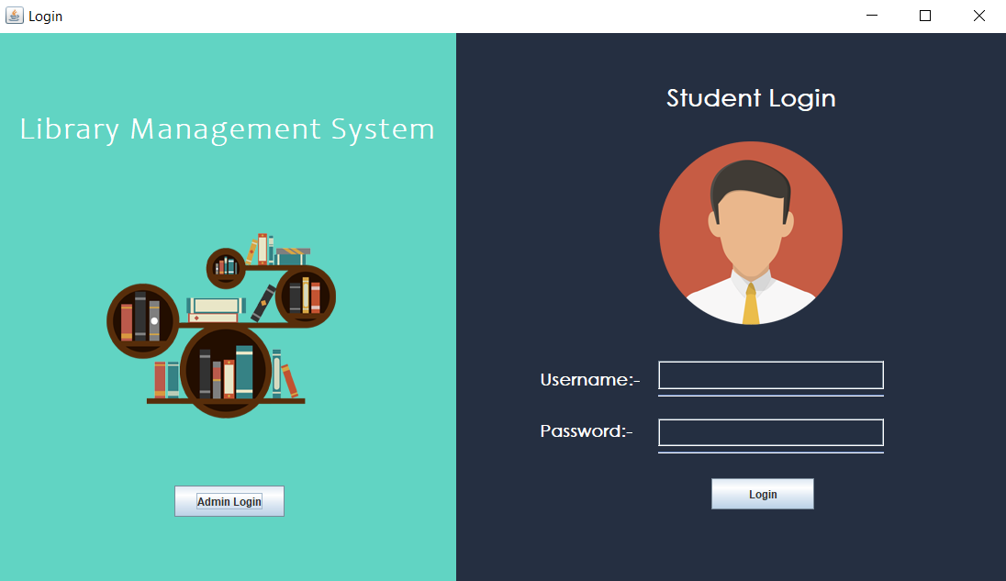**1.Login page: -**

**Admin Input Username & Password to get login into Administrator’s Portal.**

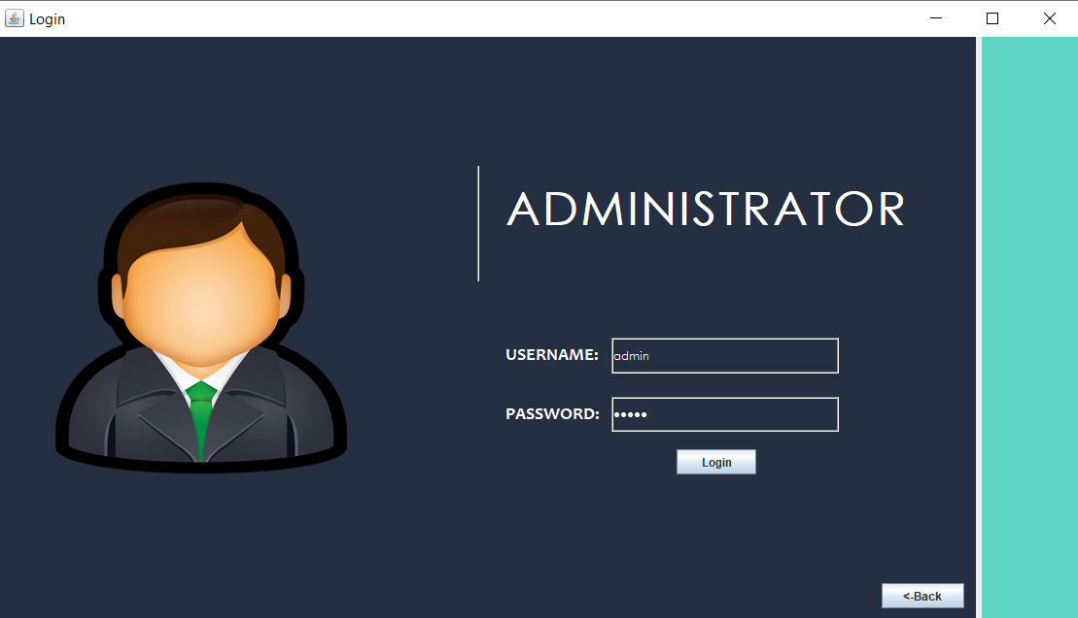

**Output for admin’s login: -** 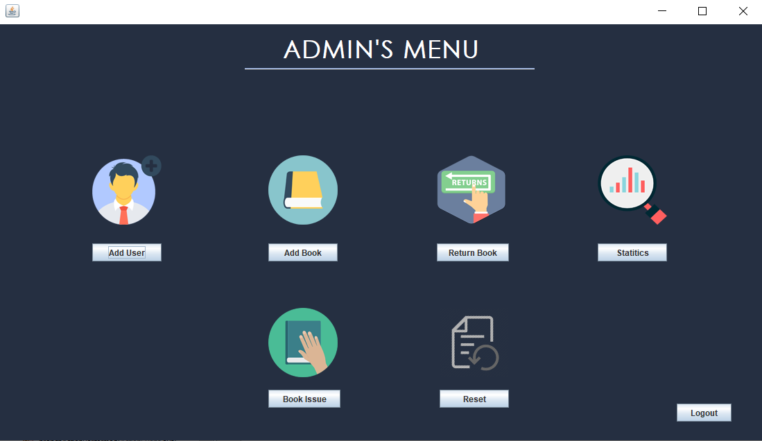

**2. Add User: -**

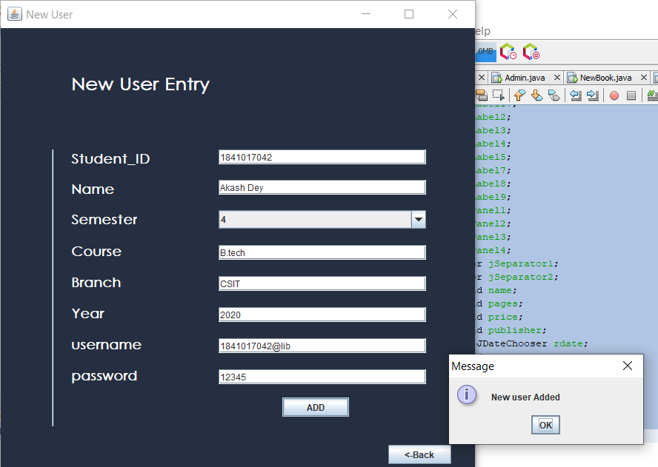

New user Entry by the Adminstrator.

**Output of add user: -** New User added in MySQL db.

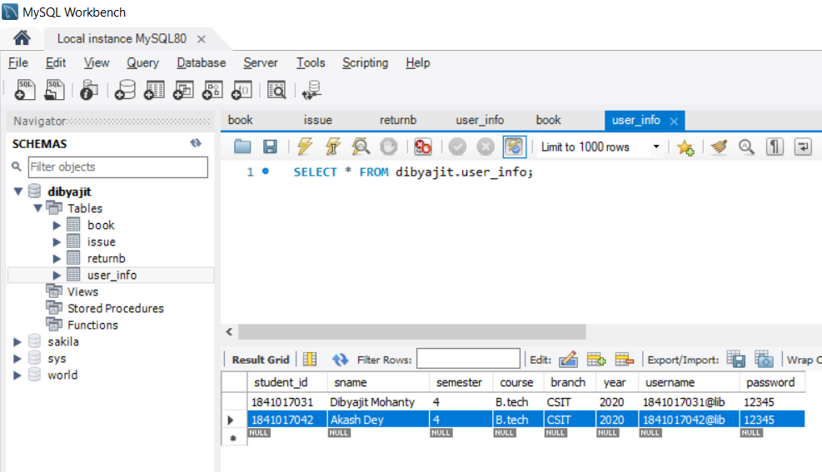

**3. ADD BOOK: -**

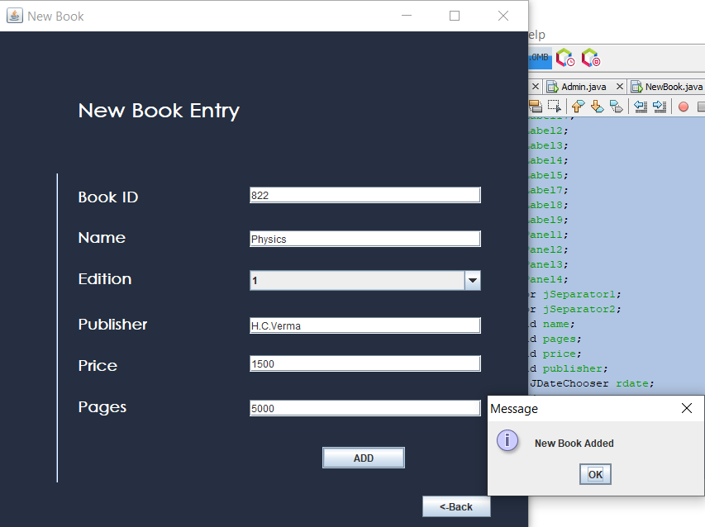

New Book Entry by the Administrator

**Output of book user: -** New User added in MySQL db.

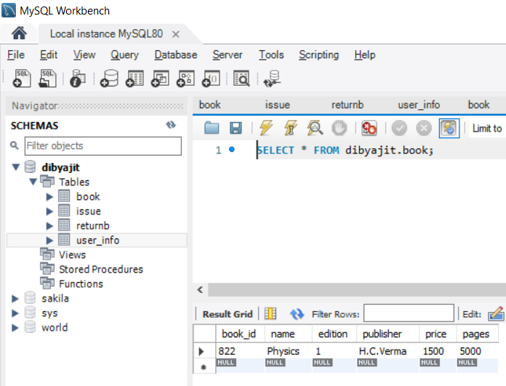

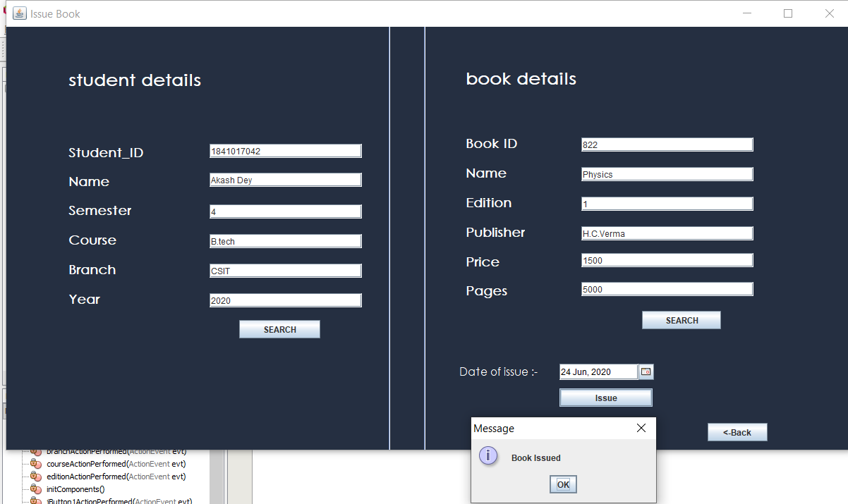**4.Issue Book: -**

**Output of Book Issue: -**

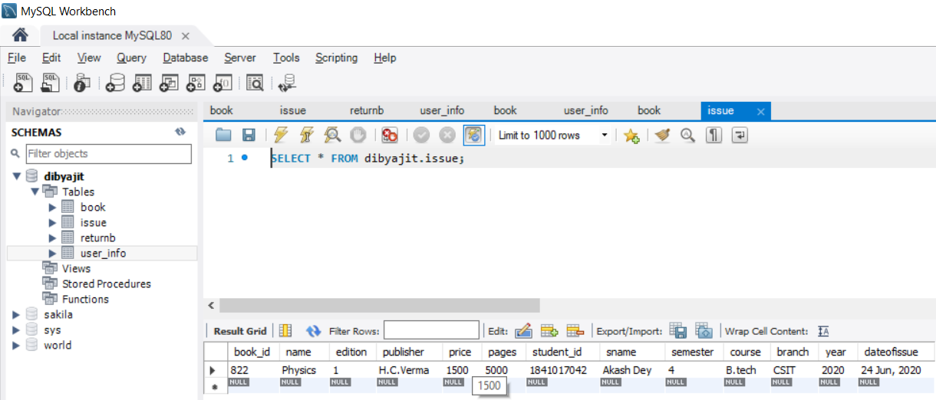

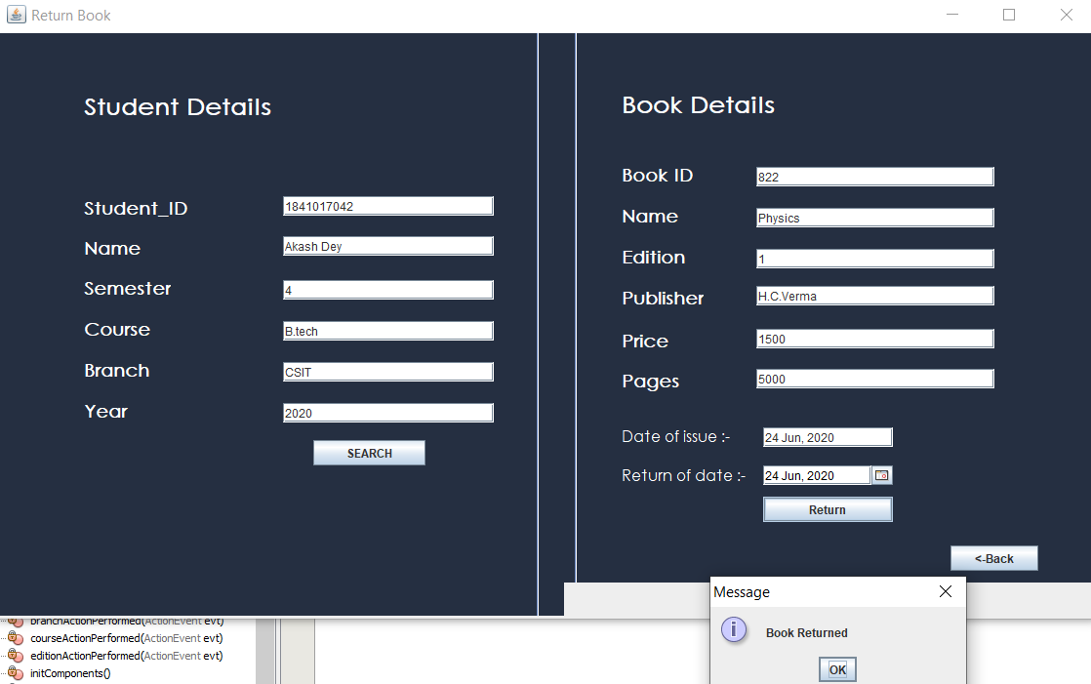**5.Return Book: -**

**Output of Return Book: -**

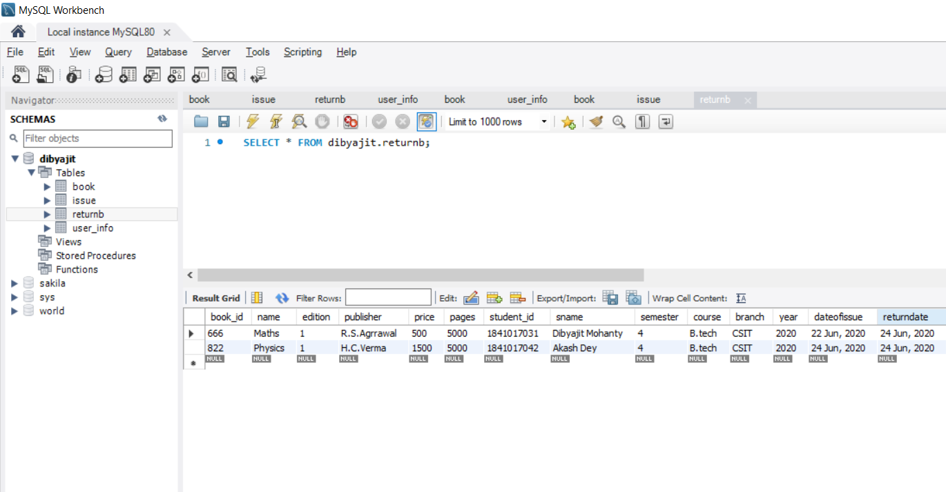

**6.Statistics: - Check the records of book issued or return & as well as delete the records .**

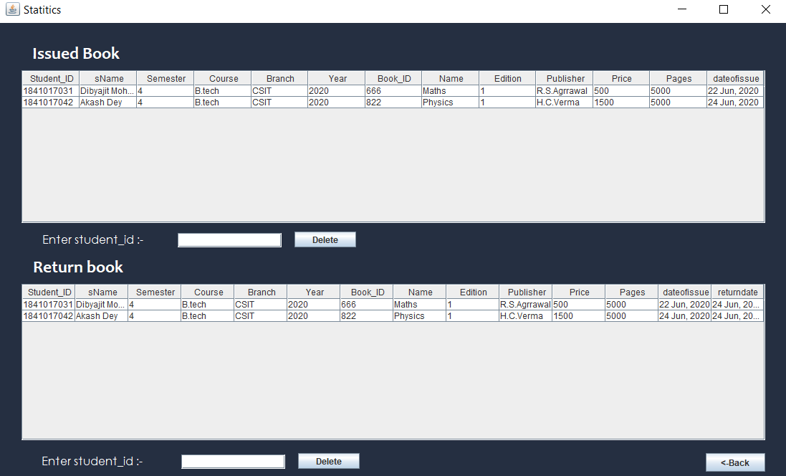

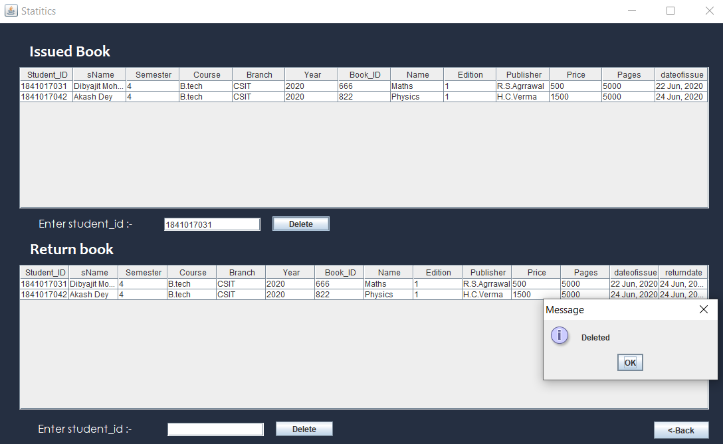**Delete the record from statistics.**

User Dibyajit is deleted from the data base.

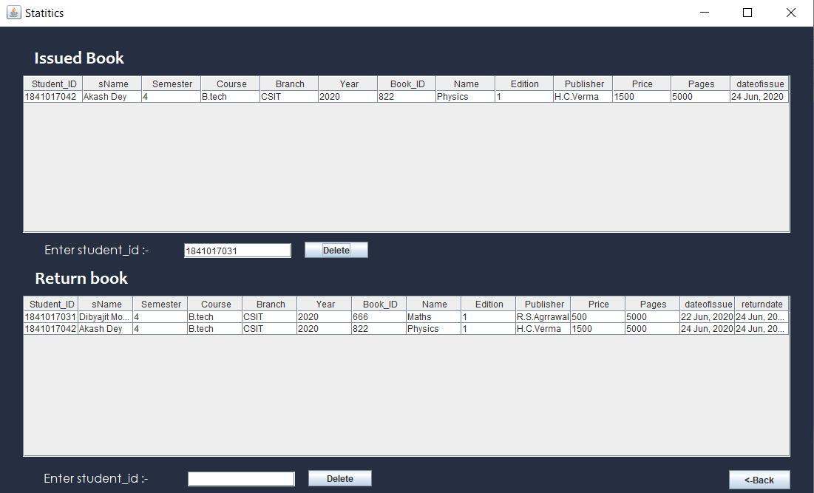

**7.Reset (Remove the user or book): -**

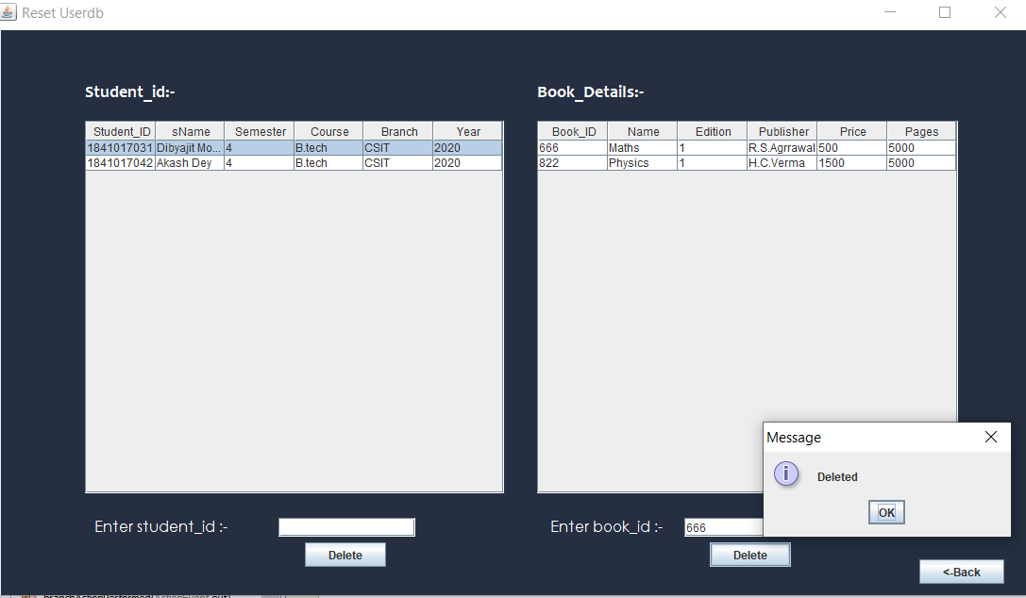

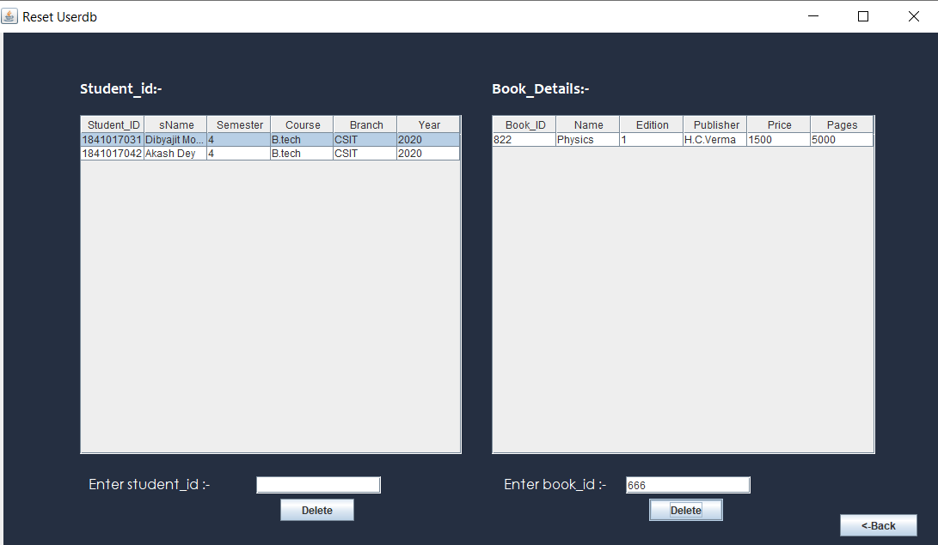Output: - Book_ID 666 is removed from database.

**8.User_Login: - User Input Username & Password to get login into User’s Portal.**

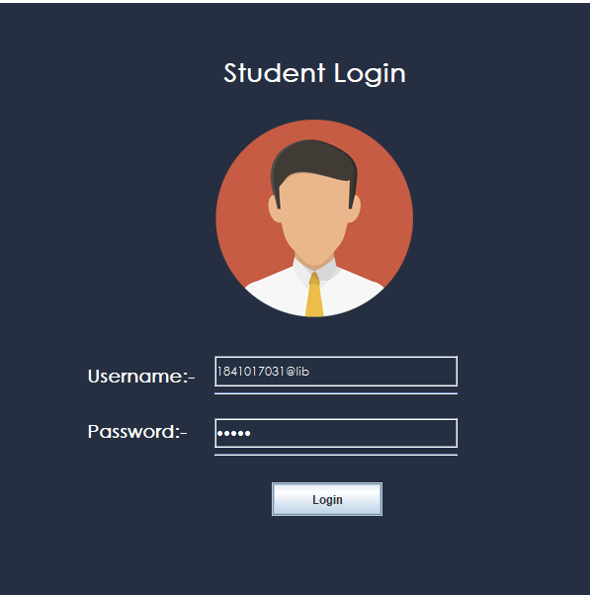

Output: - Enter to User’s Portal.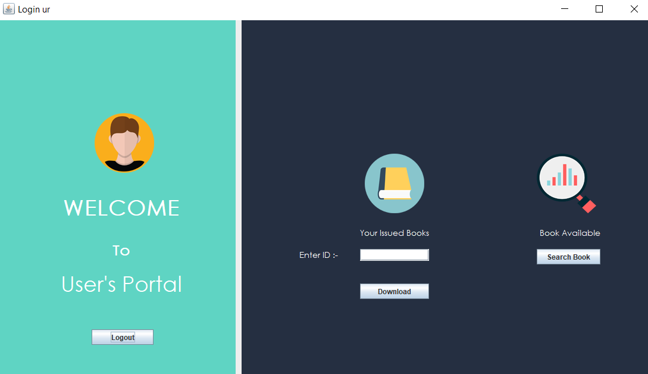

**9.Print the issued book report in .txt file: -**

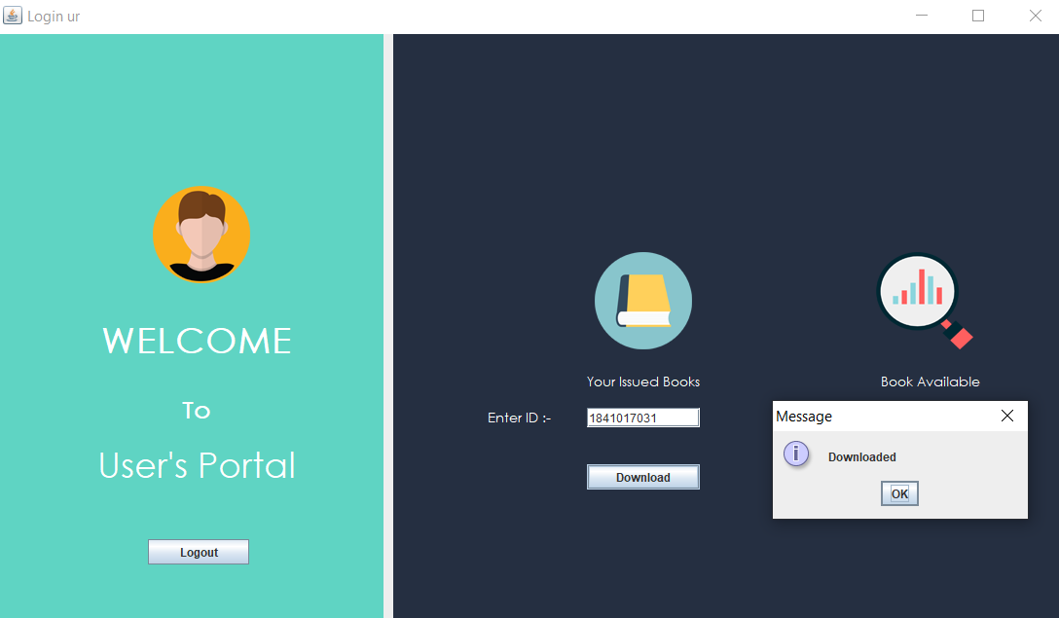

Output: You can find the report.txt file in my project doc.

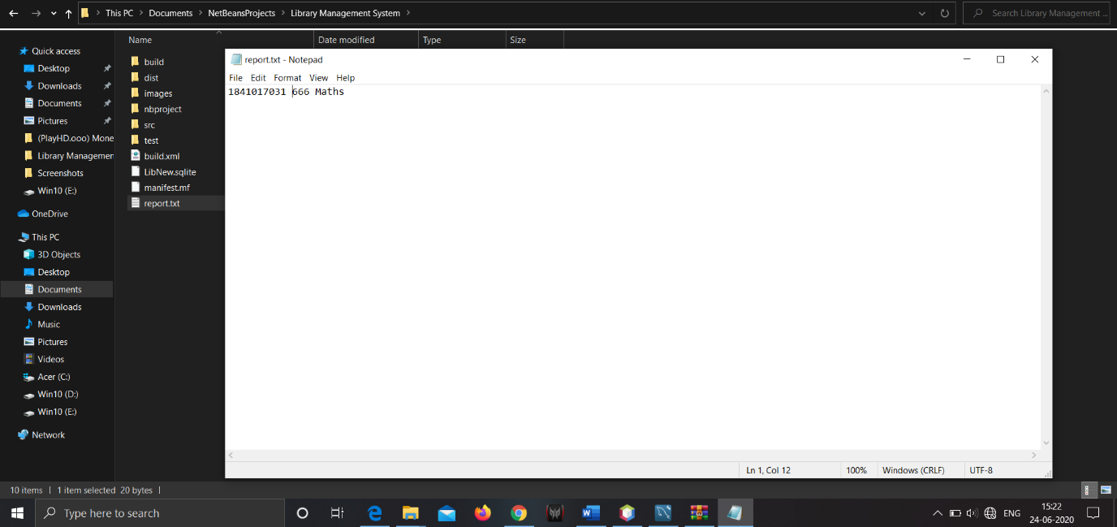

Here User see the name of the book and book_id issued.

**9.Show Available book in Library by user:-**

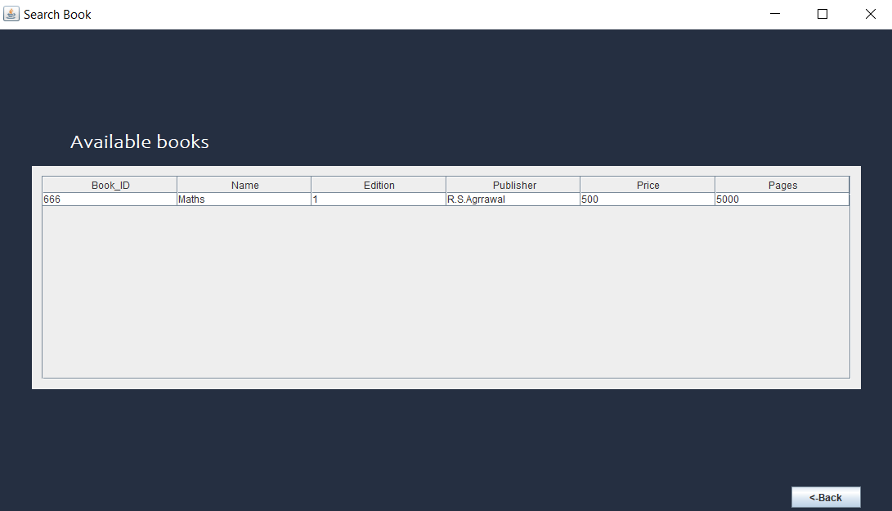

* Here in the table user can see the list of books available in the library.

--------------------E--N--D-------------------